**CONTENT**

**1. B2B2C (User)**

**1.1. B2B2C (user) signs up**

**1.2. Steps to sign up**

**1.3. Activation of B2B2C (user) account from parent agent panel**

**1.4. B2B2C (User) login**

**2. B2B2C Dashboard**

**2.1. Dashboard recent activities**

**2.2. Profile**

**2.3.** **Change the password (dashboard)**

**2.4. Traveler Information**

**2.5. Steps to add traveler**

**3. Flight**

**3.1. Search flight**

**3.2. Markup**

**3.3. Markup for B2B2C Flight**

**3.4. Before adding the Markup for flight from Admin panel and Parent agent (B2B2C)**

**3.5. Front End without adding markup (B2B2C)**

**3.6. Steps to add markup for Flight (B2BB2C) Admin panel and agent panel**

**3.7. Markup list admin panel and agent panel for B2B2C**

**3.8.** **Front end with Markup (B2B2C)**

**3.9. Booking for Flight (B2B2C)**

**3.9.1. Voucher page for Flight (B2B2C)**

**4. HOTEL**

**4.1. Search hotel**

**4.2. Hotel displayed on front end**

**4.3. MARKUP for Hotel (B2B2C)**

**4.4. Before adding the Markup for Hotel Admin panel and parent agent panel (B2B2C)**

**4.5. Front End without adding markup (B2B2C)**

**4.6. Steps to add markup for hotel (B2B2C) Admin panel and agent panel**

**4.7. Front end with Markup (B2B2C)**

**4.8. Booking for Hotel (B2B2C)**

**4.9. Voucher page for Hotel (B2B2C)**

**5. CAR**

**5.1. Search car**

**5.2. Car displayed on Front End**

**5.3. MARKUP for Car**

**5.4. Before adding the Markup for car**

**5.5. Add markup step by step**

**5.6. Front End without adding markup (B2B2C)**

**5.7. Markup list in admin and parent agent panel for B2B2C**

**5.8. Front end with Markup (B2B2C)**

**5.9. Booking for Car**

**5.9.1. Voucher page**

**6. BUNDLE DEALS**

**6.1. Bundle deal (B2B2C) (Flight, hotel, car)**

**6.2. Front End (B2B2C)**

**6.3. Booking Page (B2B2C)**

**6.4. Voucher Page (B2B2C)**

**6.5. MARKUP for Bundle deals (B2B2C)**

**6.6. Before adding the Markup for bundle**

**6.7. Front End without adding markup (B2B2C)**

**6.8. Steps to add markup for bundle (B2B2C)**

**6.9. Front end with Markup (B2B2C)**

**7. (Flight, Hotel)**

**7.1. Front End (B2B2C)**

**7.2. Booking Page (B2B2C)**

**7.3. Voucher Page (B2B2C)**

**7.4. MARKUP for Bundle deals (B2B2C)**

**7.5. Before adding the Markup for bundle**

**7.6. Front End without adding markup (B2B2C)**

**7.7. Steps to add markup for bundle (B2B2C)**

**7.8. Front end with Markup (B2B2C)**

**8. (Hotel Car)**

**8.1. Front End (B2B2C)**

**8.2. Booking Page (B2B2C)**

**8.3. Voucher Page (B2B2C)**

**8.4. MARKUP for Bundle deals (B2B2C)**

**8.5. Before adding the Markup for bundle**

**8.6. Front End without adding markup (B2B2C)**

**8.7. Steps to add markup for bundle (B2B2C)**

**8.8. Front end with Markup (B2B2C)**

**9. BOOKINGS (B2B2C dashboard)**

**9.1. Check flight booking**

**9.2. Check hotel booking**

**9.3. Check bundle deals booking**

**1. B2B2C (User)**

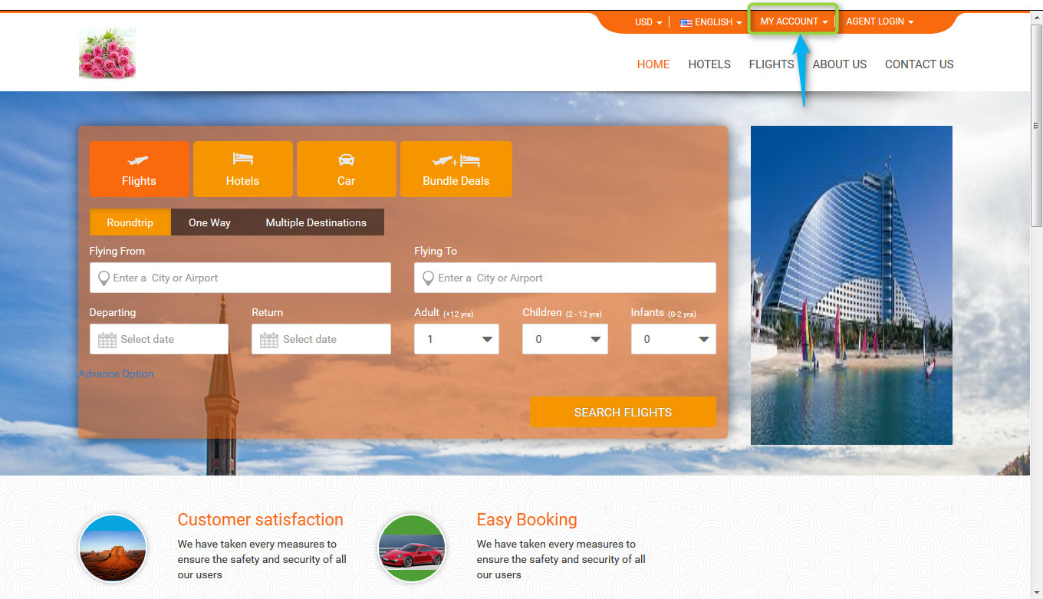

* 1. **B2B2C (user) signs up:** user can sign up from front end and the email address that customer has given at the time of sign up it will display in list (B2C user in parent agent control panel). And agent has to activate that email address after that user will be able to login.
  2. **Steps to sign up :** Click onmy account login ,now click on sign upand enter the name, email address ,password, select the country, enter the city name and click on sign up.

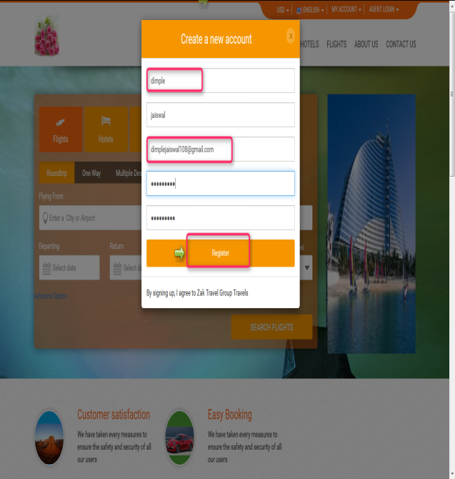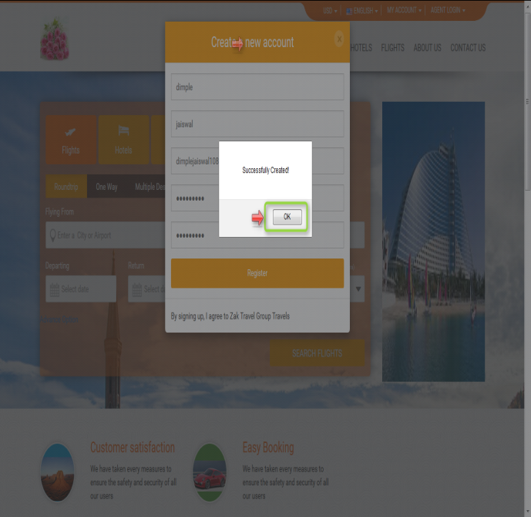

* 1. **Activation of B2B2C (user) account from parent agent panel:** After signing up for customerthe email address that user has given at the time of sign up it will display in agent b2c user list (B2C user management). And agent has to activate that email address after that user will be able to login.

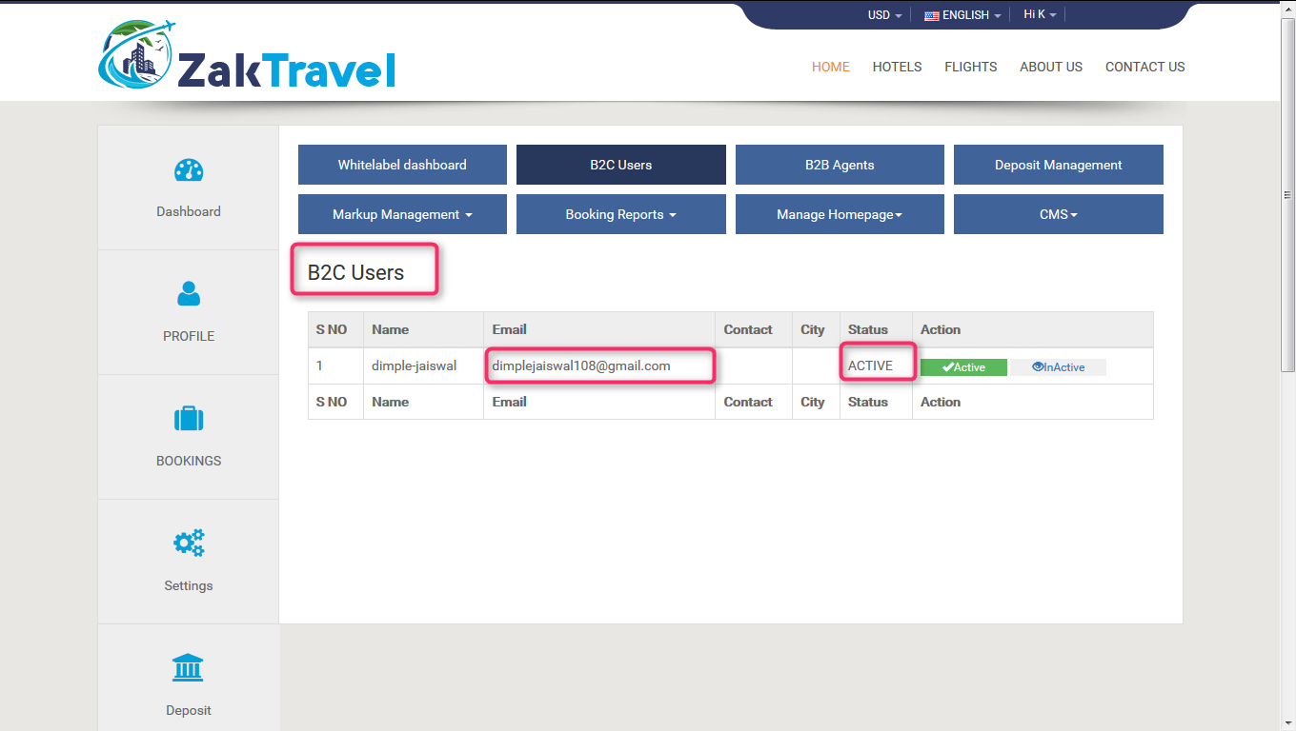

* 1. **B2B2C (User) login:** After activation of the account, customer can be login using the same credential.

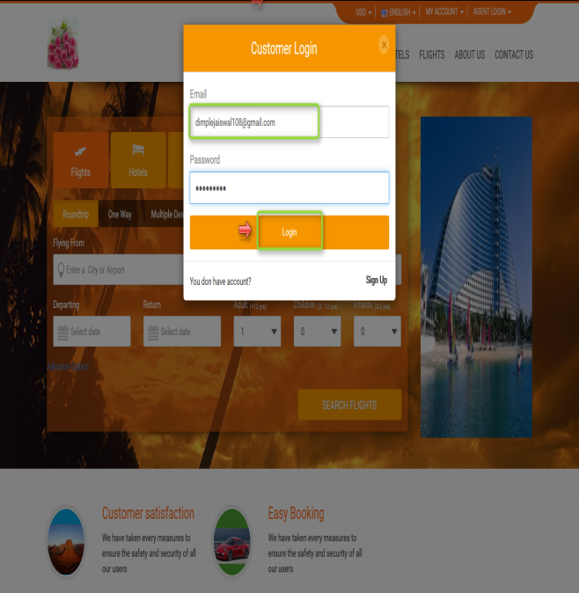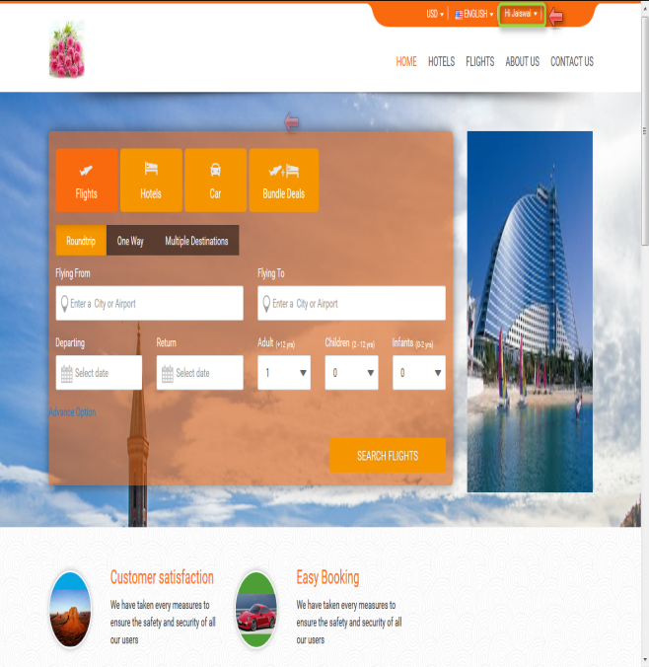

**2.B2B2C Dashboard :** The B2B2C user can login using his credentials to view the dashboard, where he can able to maintain or edit his complete personal details and booking details...- After Login Go to header menu select “customer name->dashboard “to see the B2B2C dashboard. In dashboard home user can see the progress of his booking and overall status.

**2.1. Dashboard recent activities:** Status of booked flight, hotel, car, and bundle will be displayed.

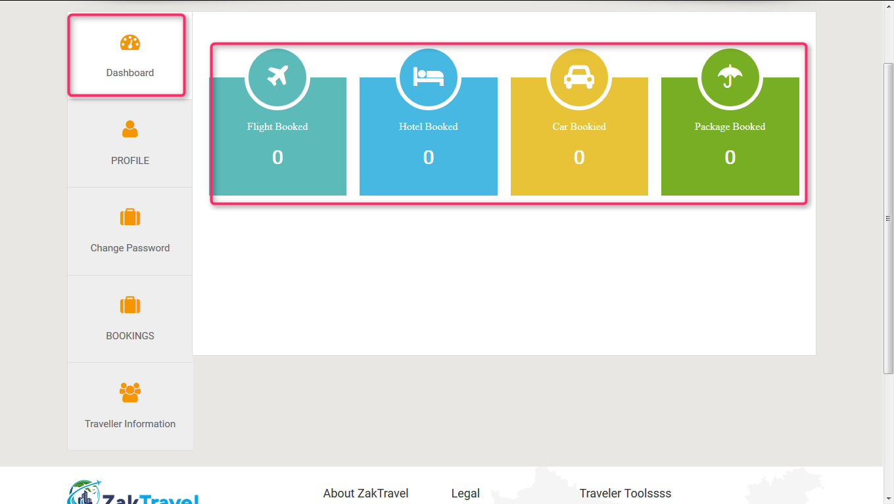

**2.2. Profile:** Customer is able to edit there profile. Profile page where user can edit the personal details. Bookings page shows all booking details with respect to each module.

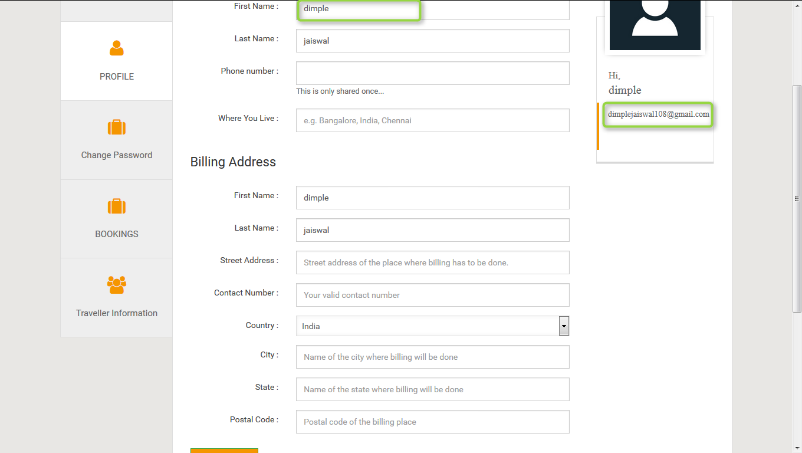

**2.3.** **Change the password (dashboard):** Here user can change their account password and can login with the current (Changed) password.

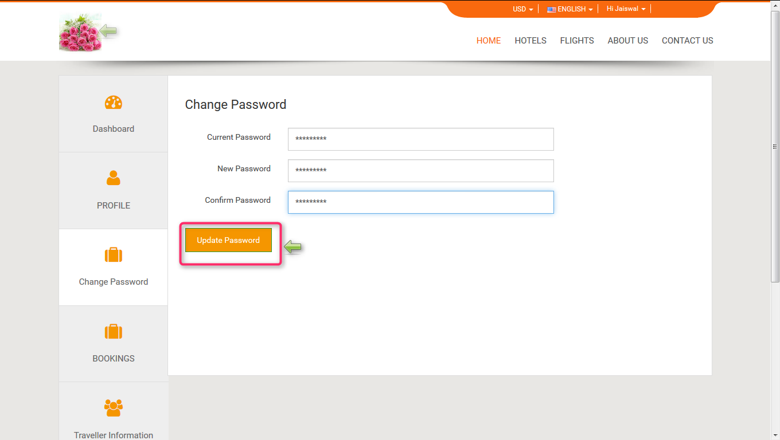

**2.4. Traveler Information:** Here customer needs to add the detail it contain Name, type, DOB, email, action.

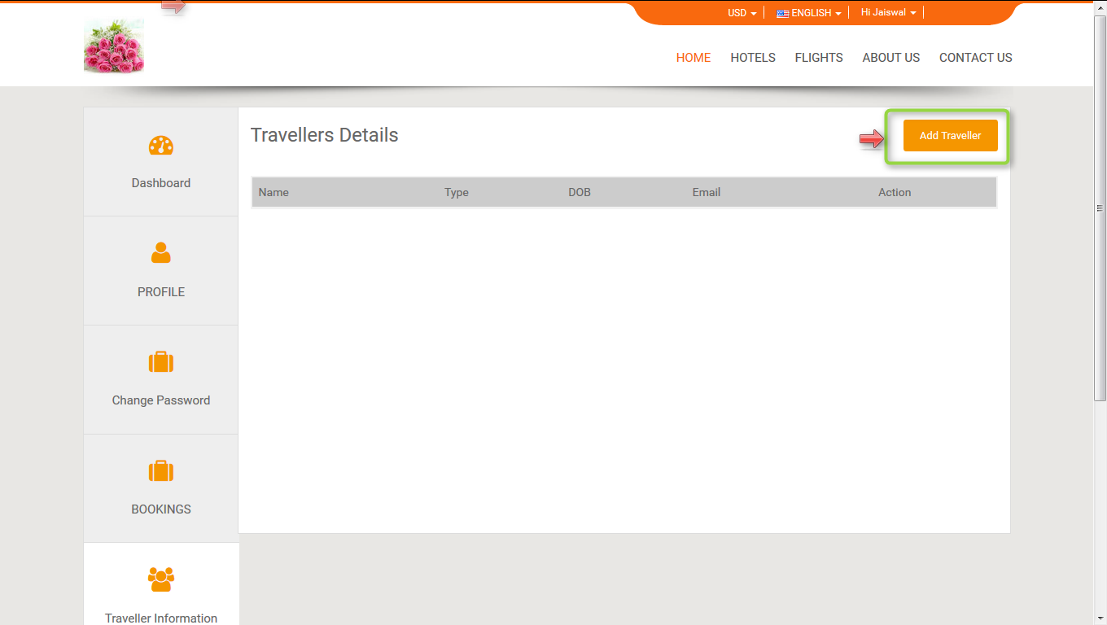

**2.5. Steps to add traveler:** Click on add traveler, enter name, type (Adult, child, infant), date of birth, email Click on next.

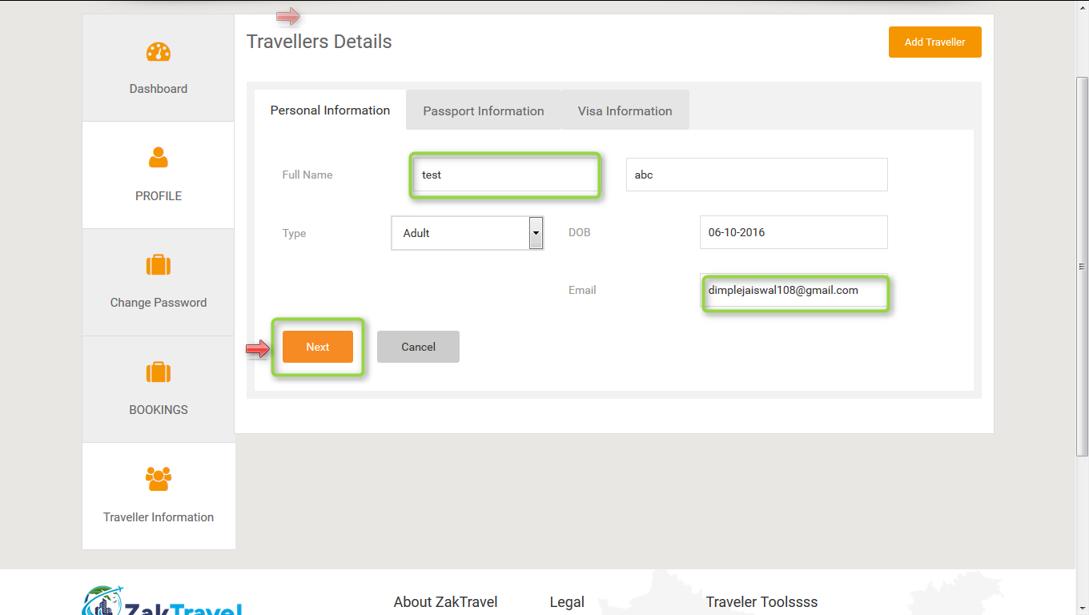

Now click on next button it will navigate to the passport information tab, select the issuing country, passport nationality, date of expiry and click on next button.

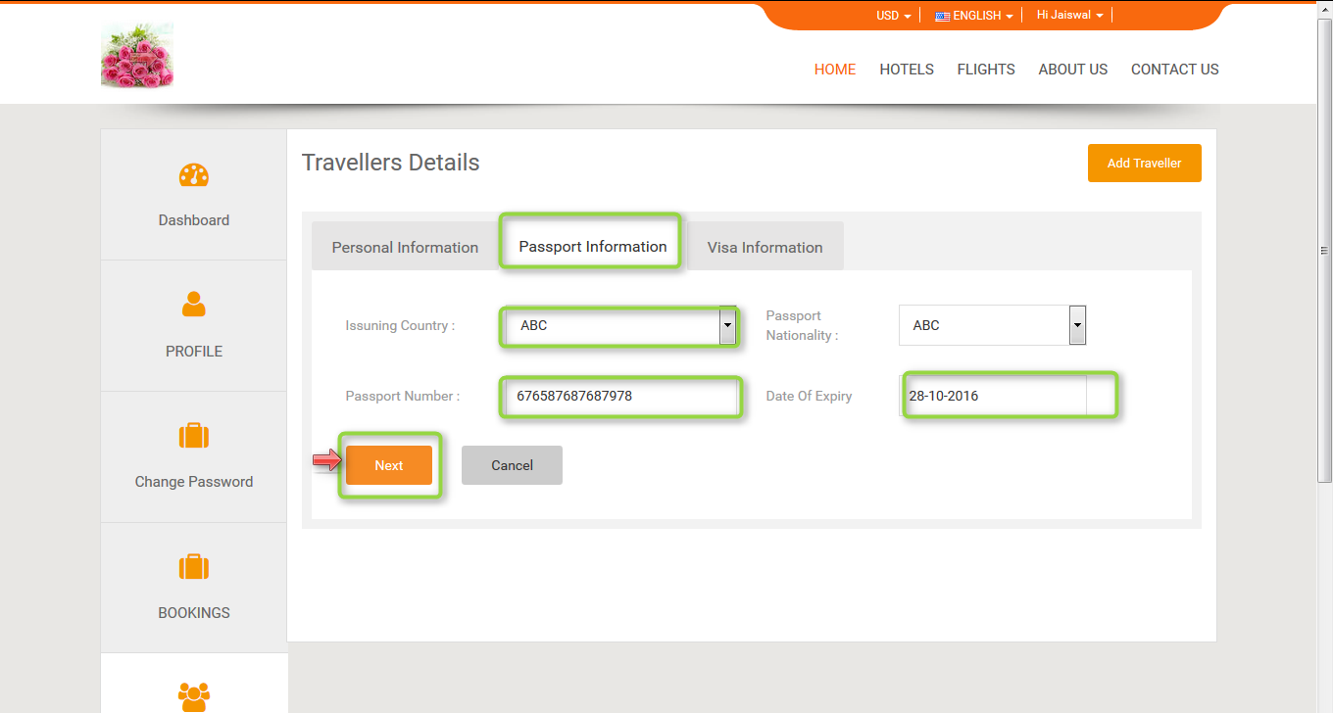

After click on next button it will navigate to the visa information page. Enter issuing country, visa information, Date of expiry and click on submit button.

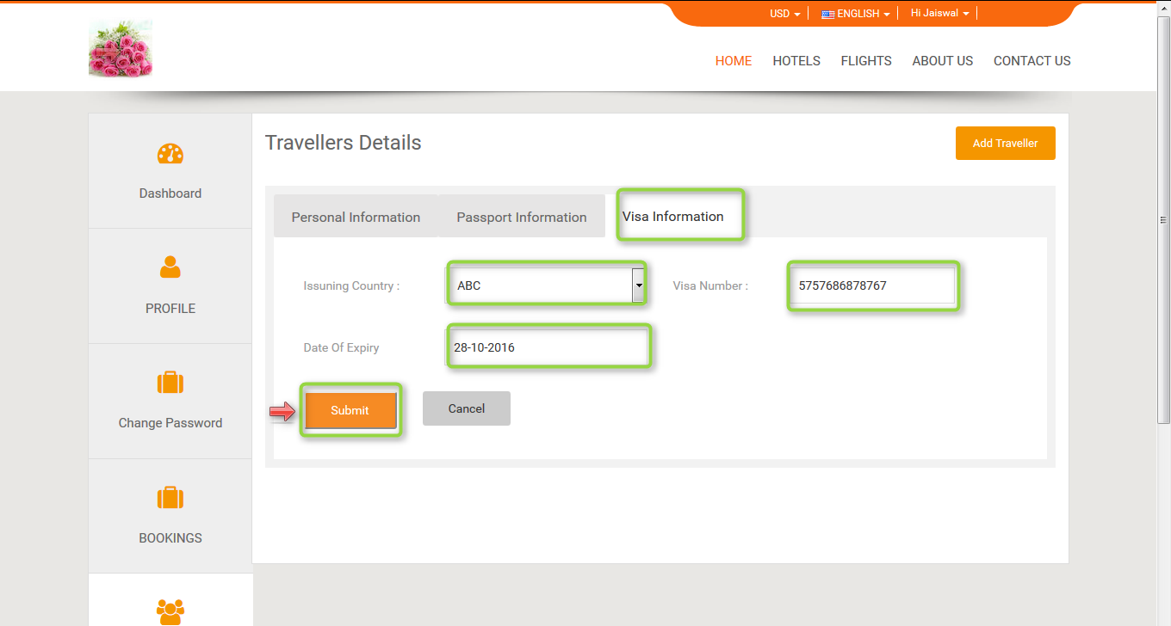

Added traveler will be displayed in the travelers list.

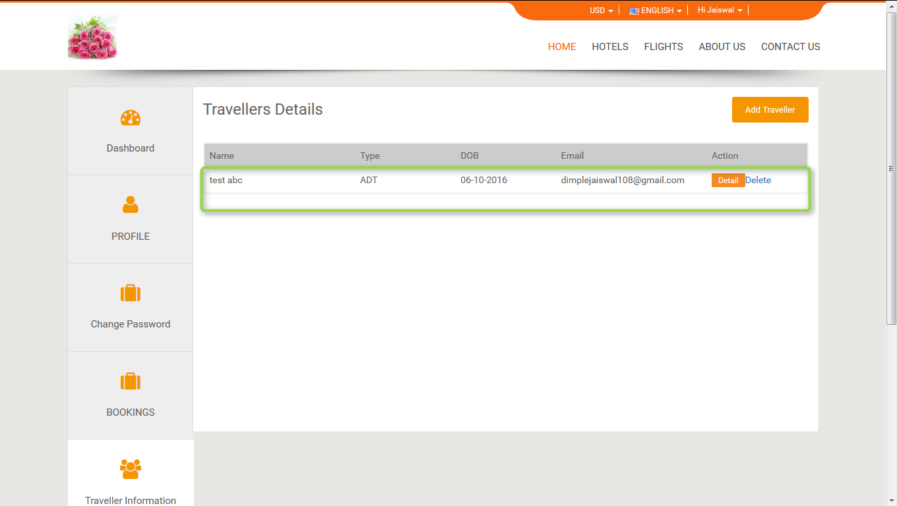

**3. Flight**

**3.1. Search flight:** Enter the flying from and flying to, select the departure time and click on search flight.

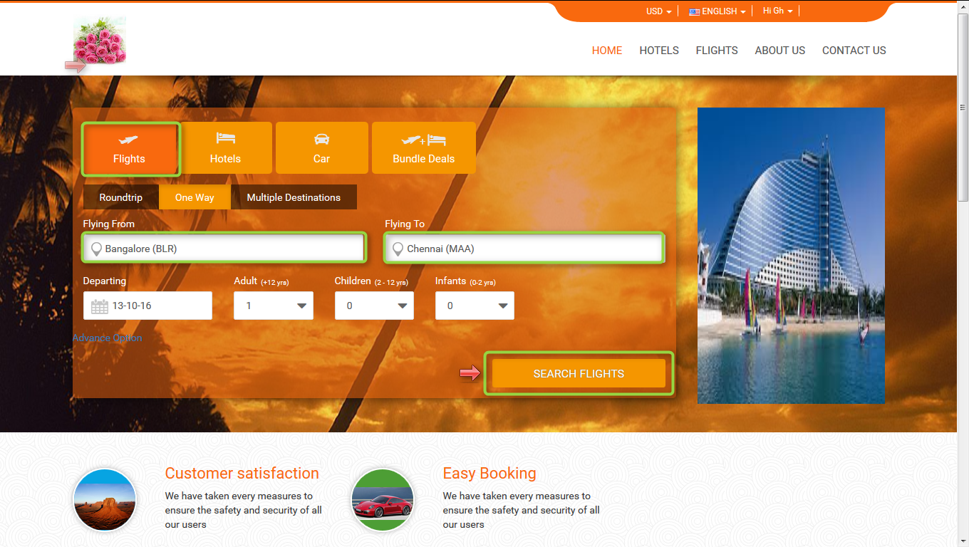

Search result display on front end.

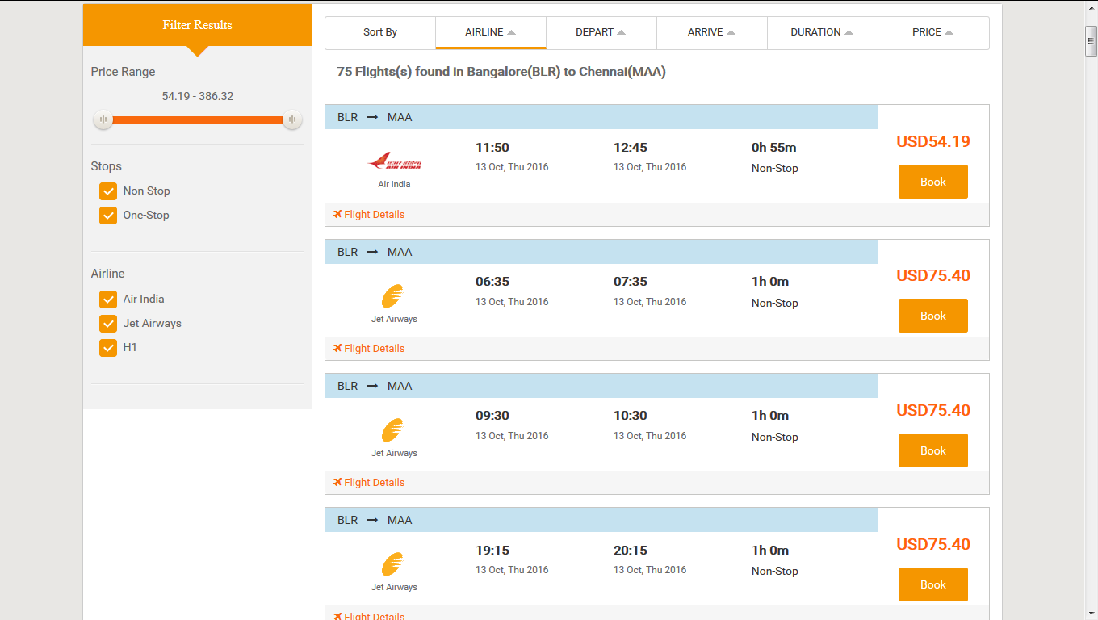

**3.2. Markup:** Markup is added by the Admin and parent agent, after adding the markup will be added with total fare and display on front end.

B2B2C = Admin Markup + Agent Markup

**3.3. Markup for B2B2C Flight:**

**3.4. Before adding the Markup for flight from Admin panel and Parent agent (B2B2C):** Markup will not display in the list before adding.

**Admin Parent agent**

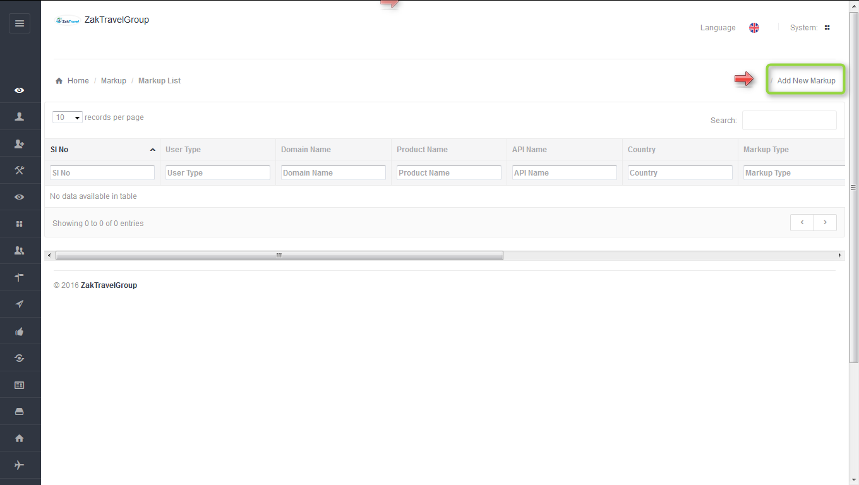 **+** 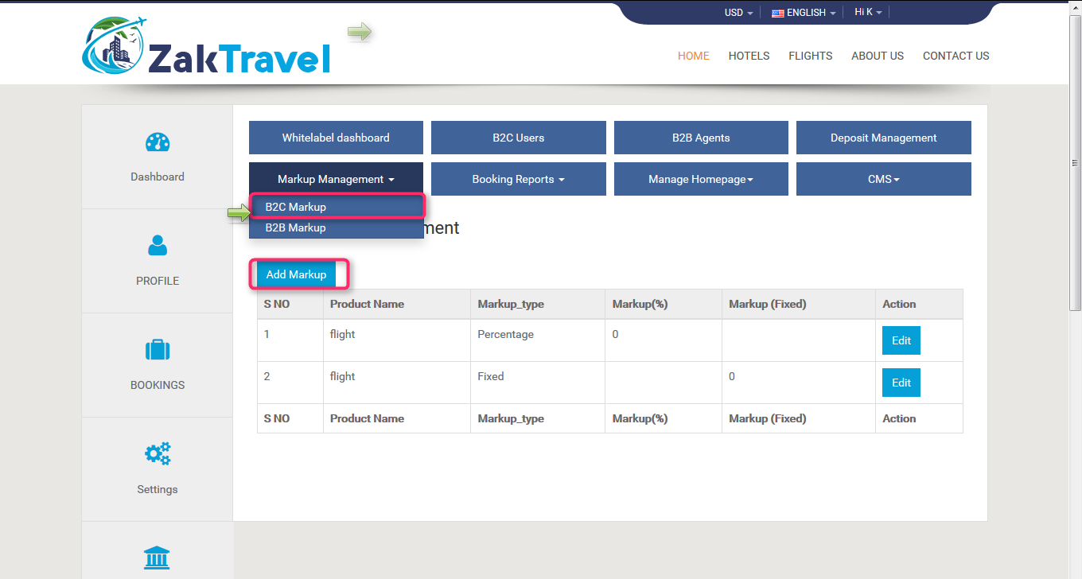

**3.5. Front End Without adding markup (B2B2C):** For customer the markup is not added with total fare so whatever the amount is added at the time of rate management that amount will be display only and total fare will display without markup.

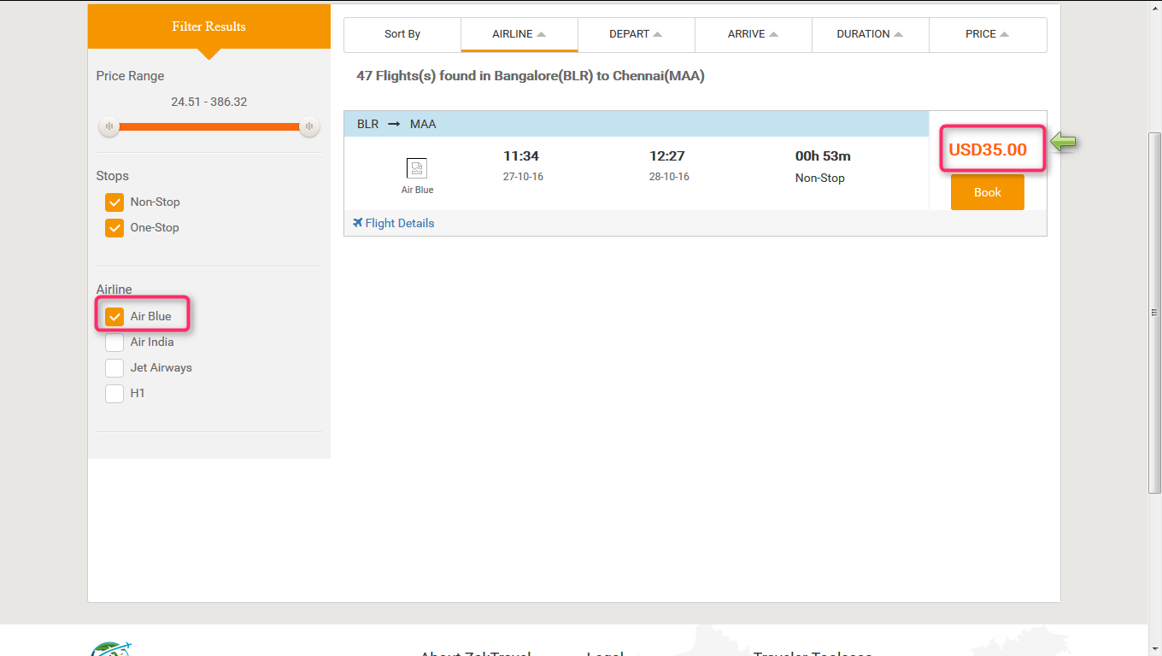

**3.6. Steps to add markup for Flight (B2BB2C) Admin panel and agent panel:** After click on add markup one form will be displayed and enter all the required information like user type, product, API, and markup value type, etc. and for agent panel select the markup type and enter the amount and click on add.

**Admin Parent agent**

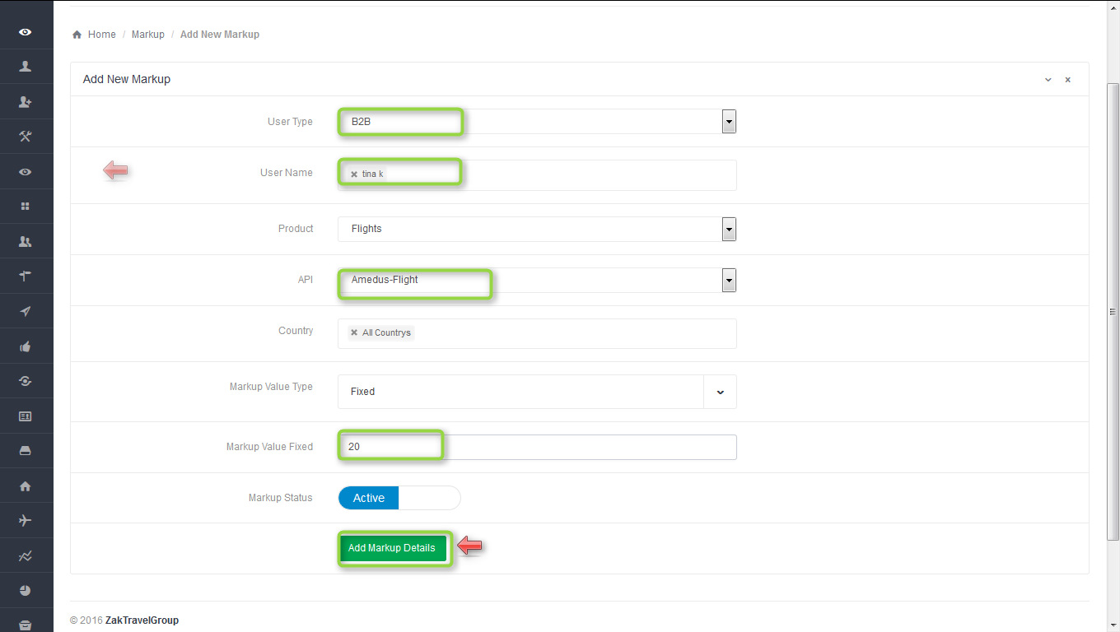**+**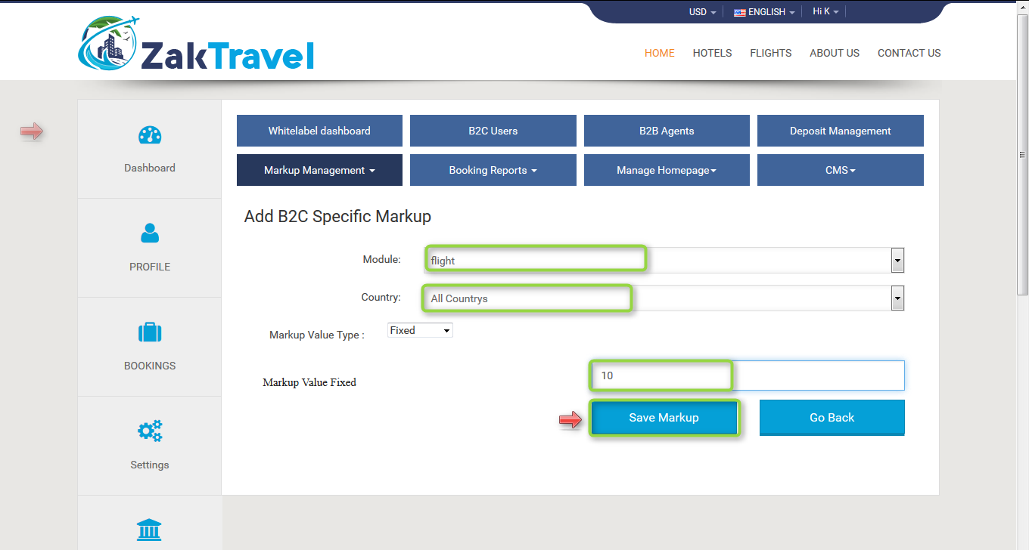

**3.7. Markup list admin panel and agent panel for B2B2C**: Here admin and parent agent add the markup (B2B2C) , select the user type as B2B , user name means for which agent admin add the markup, product as a Flight, API CRS Flight, country and markup type. After adding the markup will display in the list.

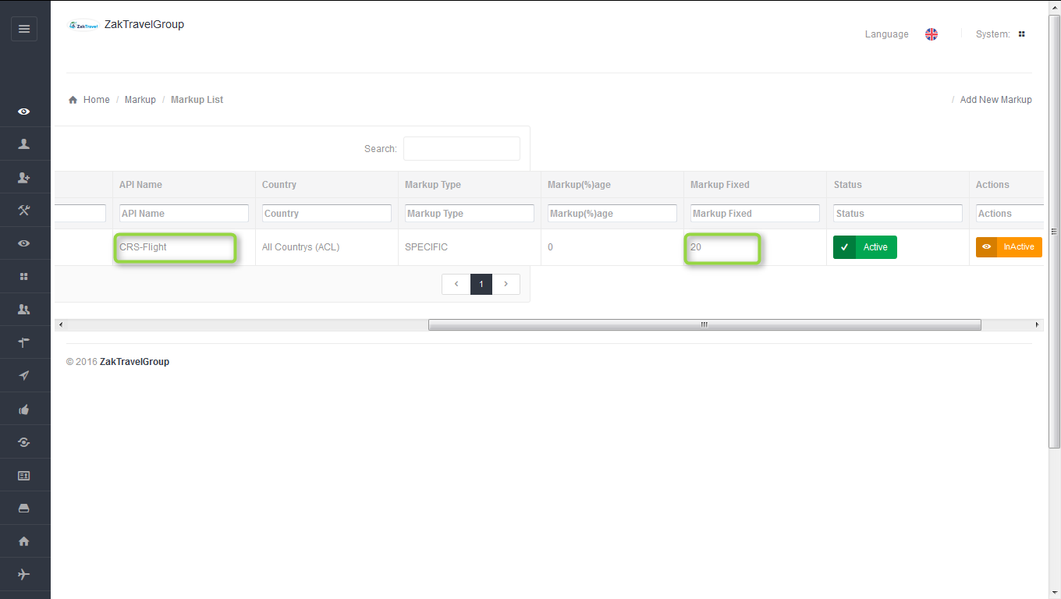**+**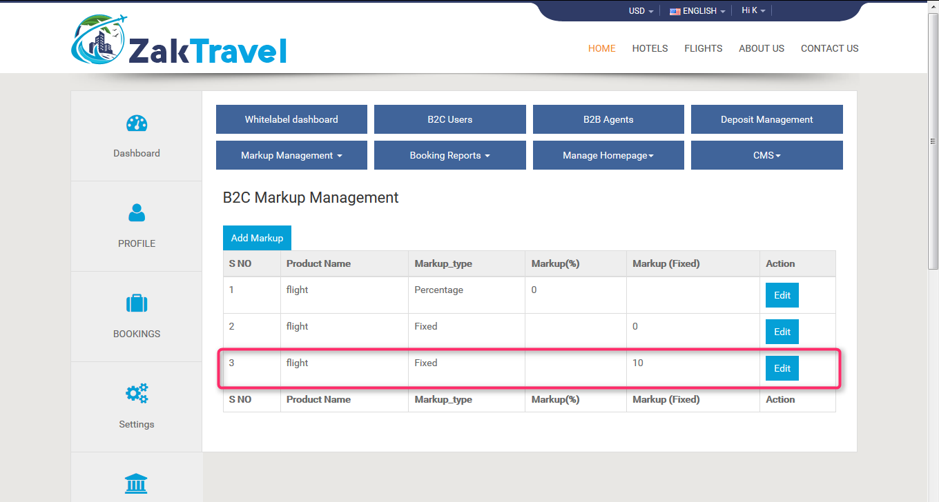

**3.8.** **Front end with Markup (B2B2C):** Now the added markup will be display with the total fare, for one day the markup added is 20(admin)+10(parent agent)+30 rupees now and markup will be added according to number of days.

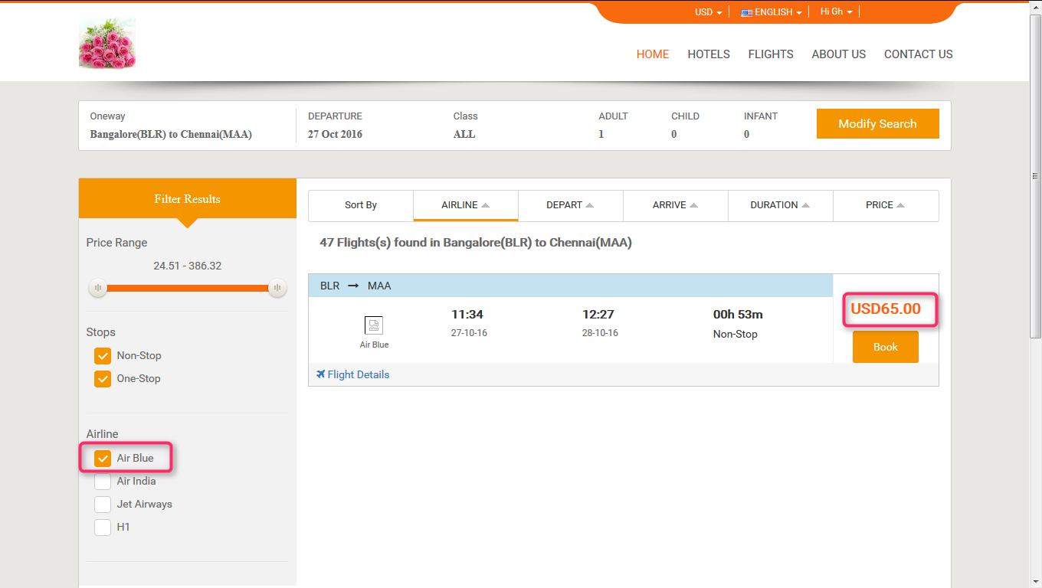

**3.9. Booking for Flight (B2B2C):**

Users can book the particular Flight by providing their personal details. And they will get confirmation letter. Now click on flight tab and provide all the valid detail and search for the Flight.



After click on search, the Flight search result will display. So click on Book button for booking the Flight

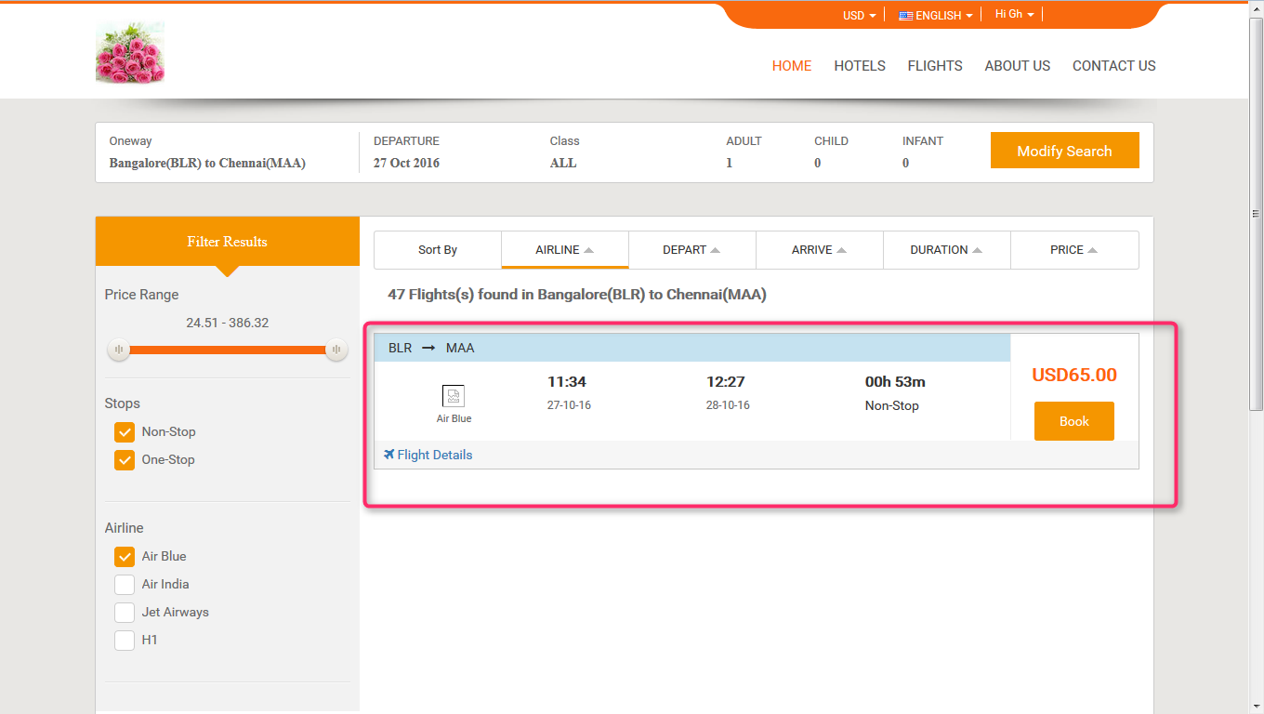

Now after click on book button it will open review, travelers and payment information and click on continue tab it will open the form to enter the personal information. Provide all the valid information and click on continue button and check the check box for terms and conditions.

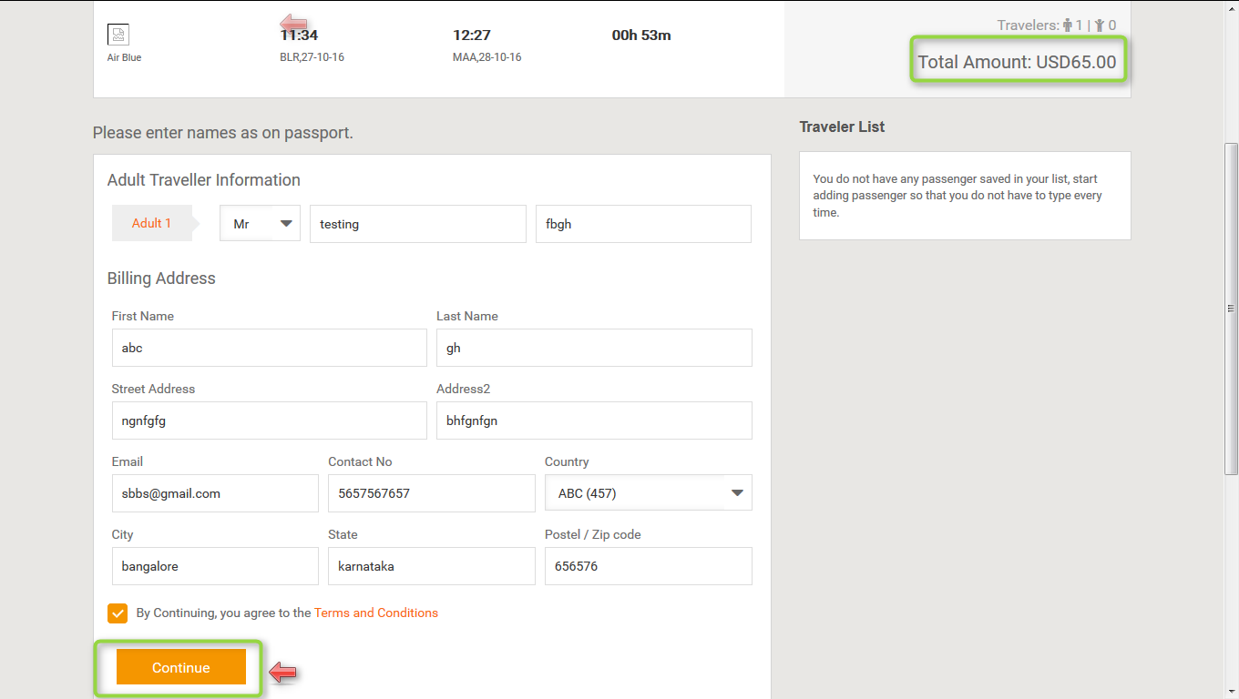

**3.9.1. Voucher page for Flight (B2B2C)**: Voucher page display after providing all the information and click on continue button and everything will be present on the voucher page like booking status, reservation number, Traveler, date, amount etc.

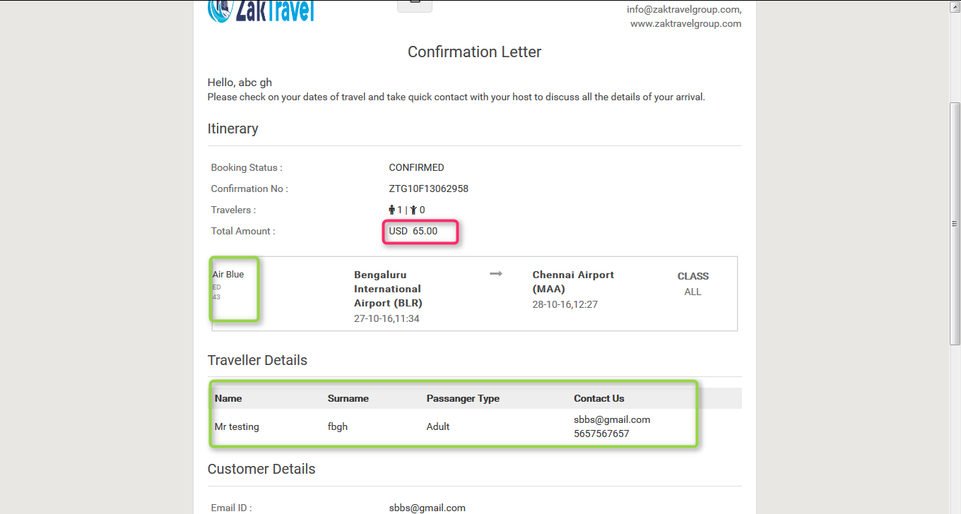

**4. HOTEL**

**4.1. Search hotel:**

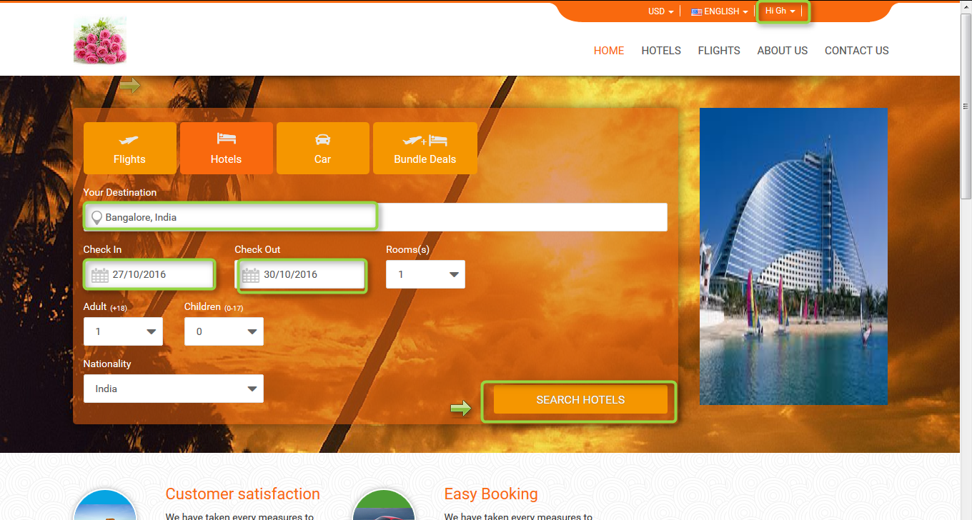

**4.2. Hotel displayed on front end:**  After search the hotel will be displayed on the front end and from where user can book.

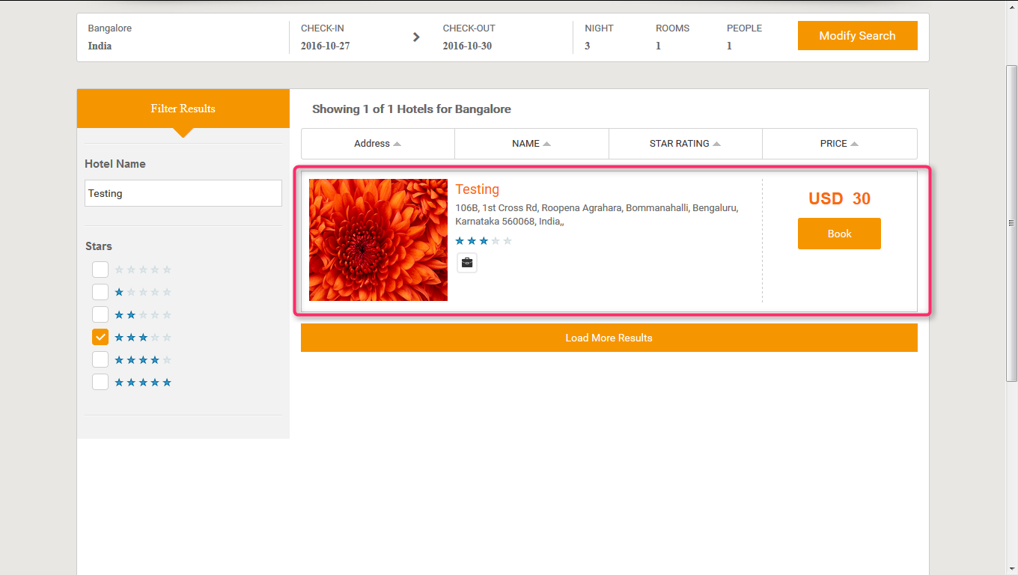

**4.3. MARKUP for Hotel (B2B2C)**: Markup is added by the Admin and parent agent, after adding the markup will be added with total fare and display on front end.

**4.4. Before adding the Markup for Hotel Admin panel and parent agent panel (B2B2C):** Markup will not display in the list before adding.

**Admin Parent agent**

**+**

**4.5. Front End Without adding markup (B2B2C):** For a Customerthe markup is not added with total fare so whatever the amount is added at the time of rate management that amount will be display only and total fare will display without markup.



**4.6. Steps to add markup for hotel (B2B2C) Admin panel and agent panel:** After click on add markup one form will be displayed and enter all the required information like user type, product, API, and markup value type, etc. and for agent panel select the markup type and enter the amount and click on add.

**Admin Parent agent**

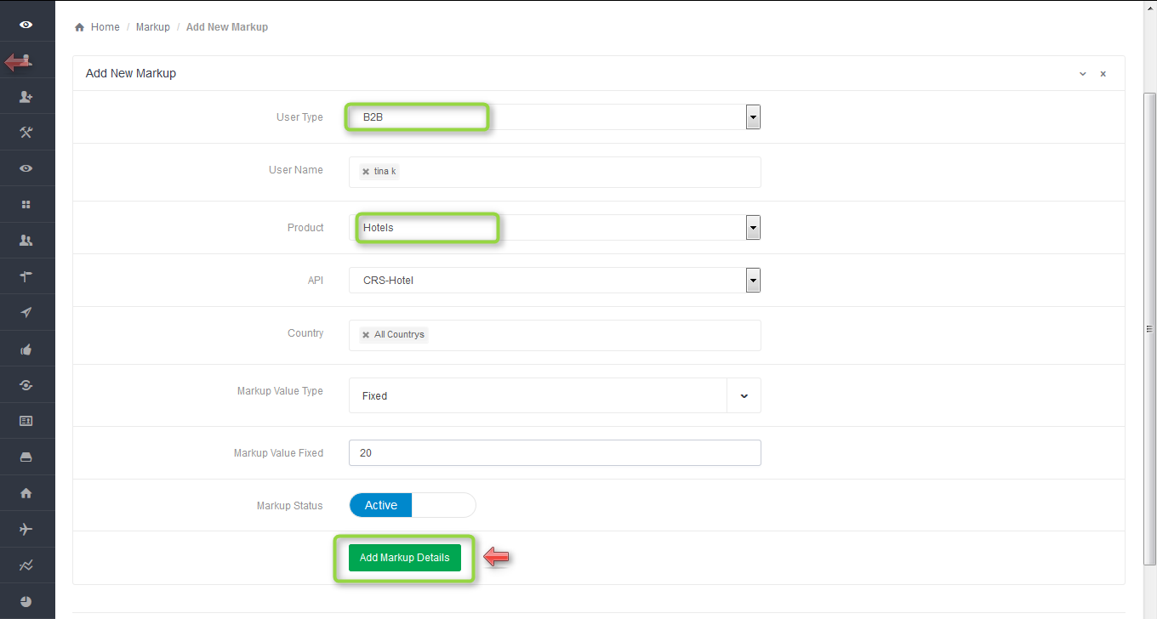**+**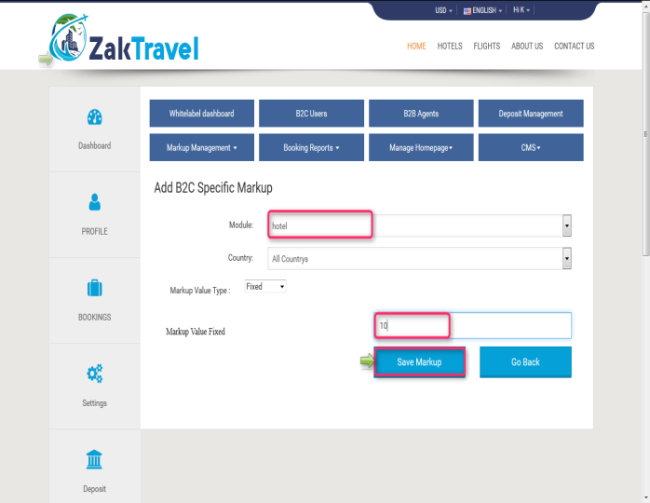

**4.7. Front end with Markup (B2B2C):** Now the added markup will be display with the total fare, for one day the markup added is 30 rupees now and markup will be added according to number of days.

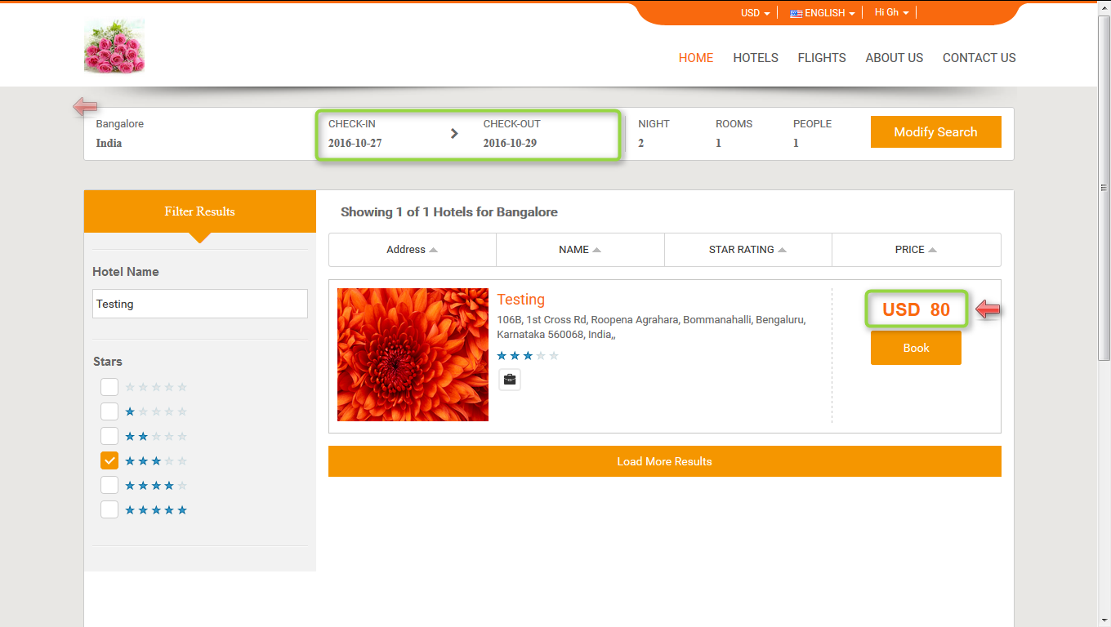

**4.8. Booking for Hotel (B2B2C):**

Users can book the particular hotel by providing their personal details. And they will get confirmation letter. Now click on hotel tab and provide all the valid detail and search for the hotel.



Now after click on book button it will open review, travelers and payment information and click on continue tab it will open the form to enter the personal information. Provide all the valid information and click on continue button and check the check box for terms and conditions.

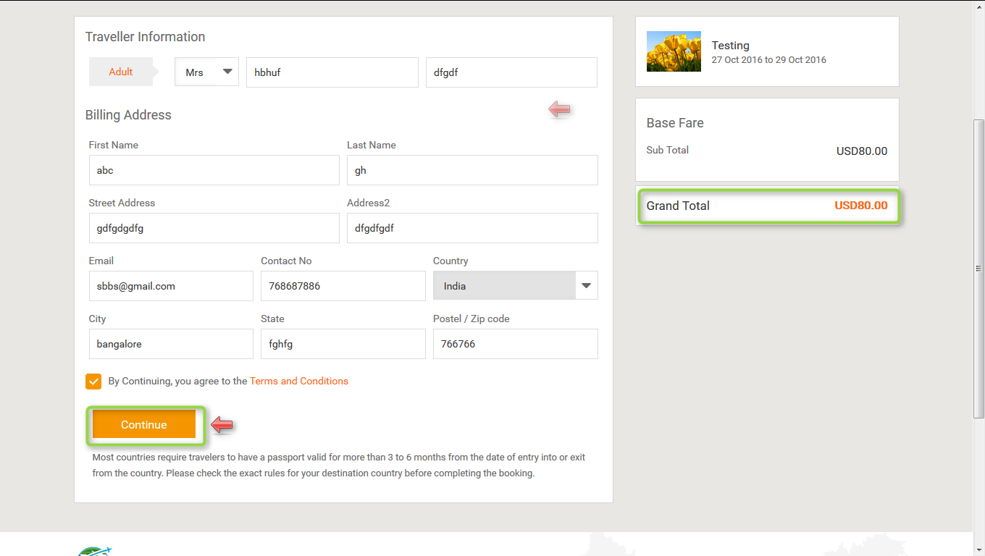

**4.9. Voucher page for Hotel (B2B2C)**: Voucher page display after providing all the information and click on continue button and everything will be present on the voucher page like booking status, reservation number, Traveler, date, amount etc.

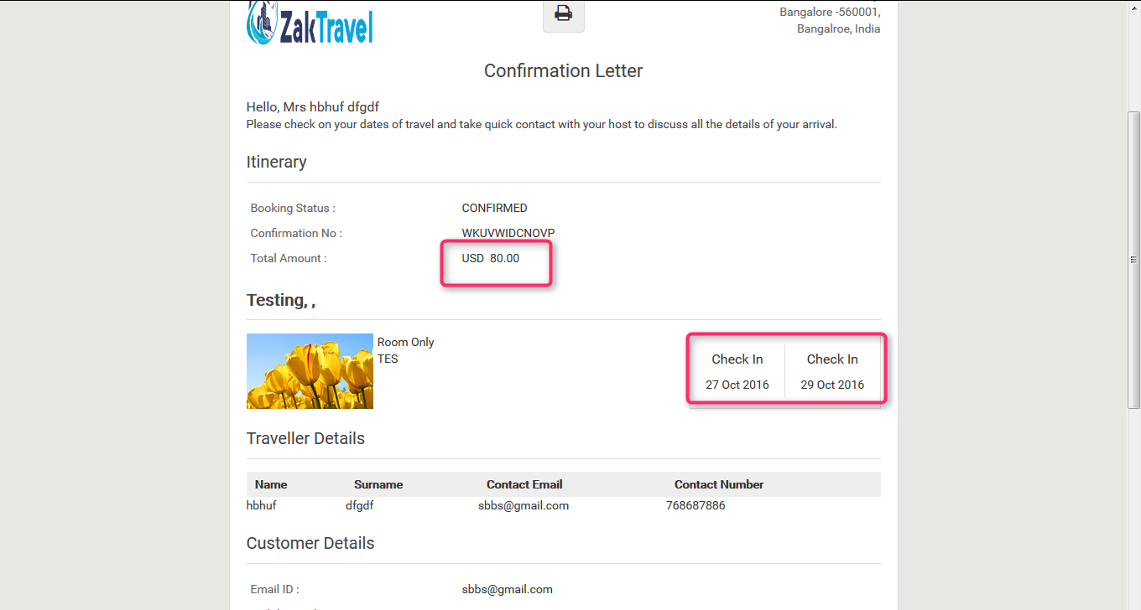

**5. CAR**

**5.1. search car:**

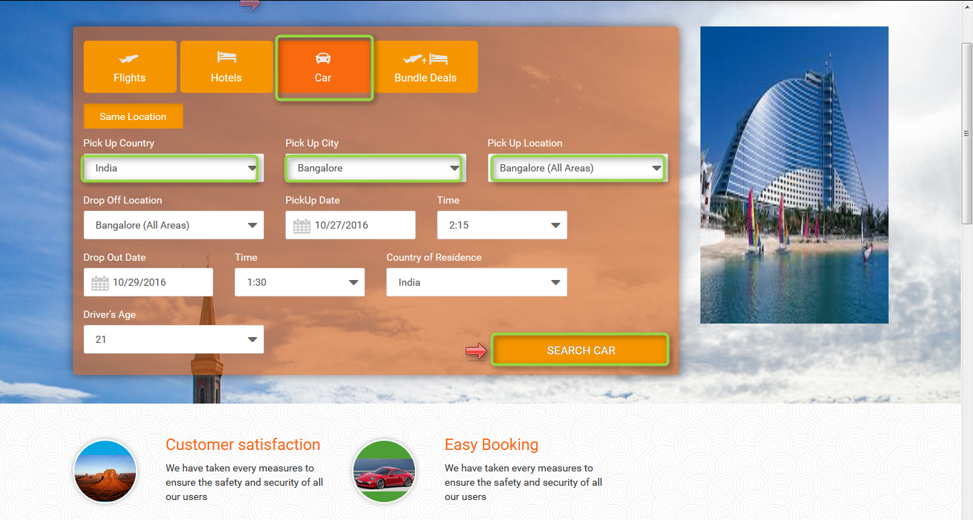

**5.2. Car displayed on Front End:** After search the transfer will be displayed on the front end and from where user can book the car.

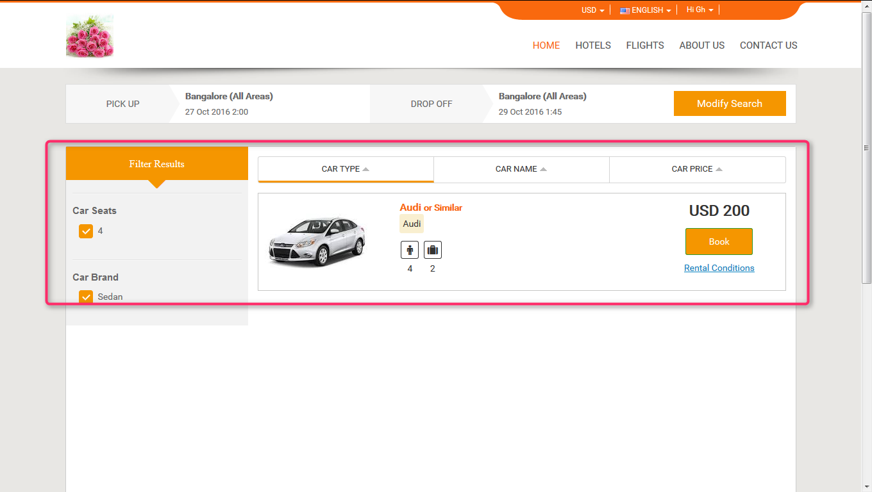

**5.3. MARKUP for Car:** Markup is added by the Admin and parent agent, after adding the markup will be added with total fare and display on front end.

**5.4. Before adding the Markup for car:** Markup will not display in the list before adding.

**Admin Parent agent**

**+**

**5.5. Add markup step by step:** After click on add markup one form will be displayed and enter all the required information like user type, product, API, and markup value type and in parent agent click on markup management and click on b2c markup, click on add markup, enter module, , select Markup Value Type and click on save markup.

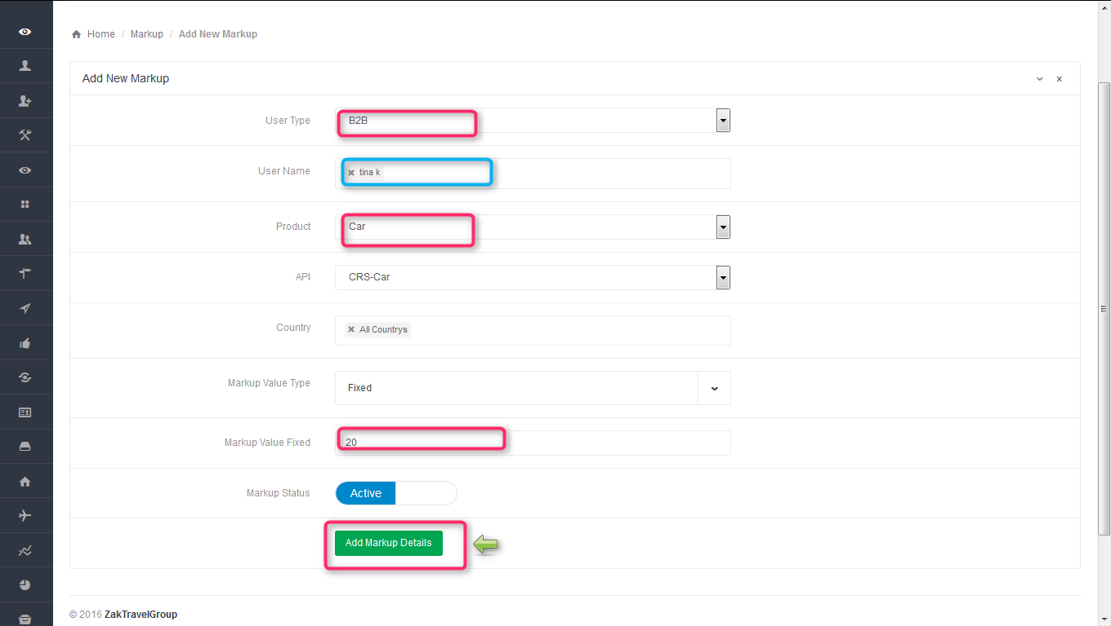**+**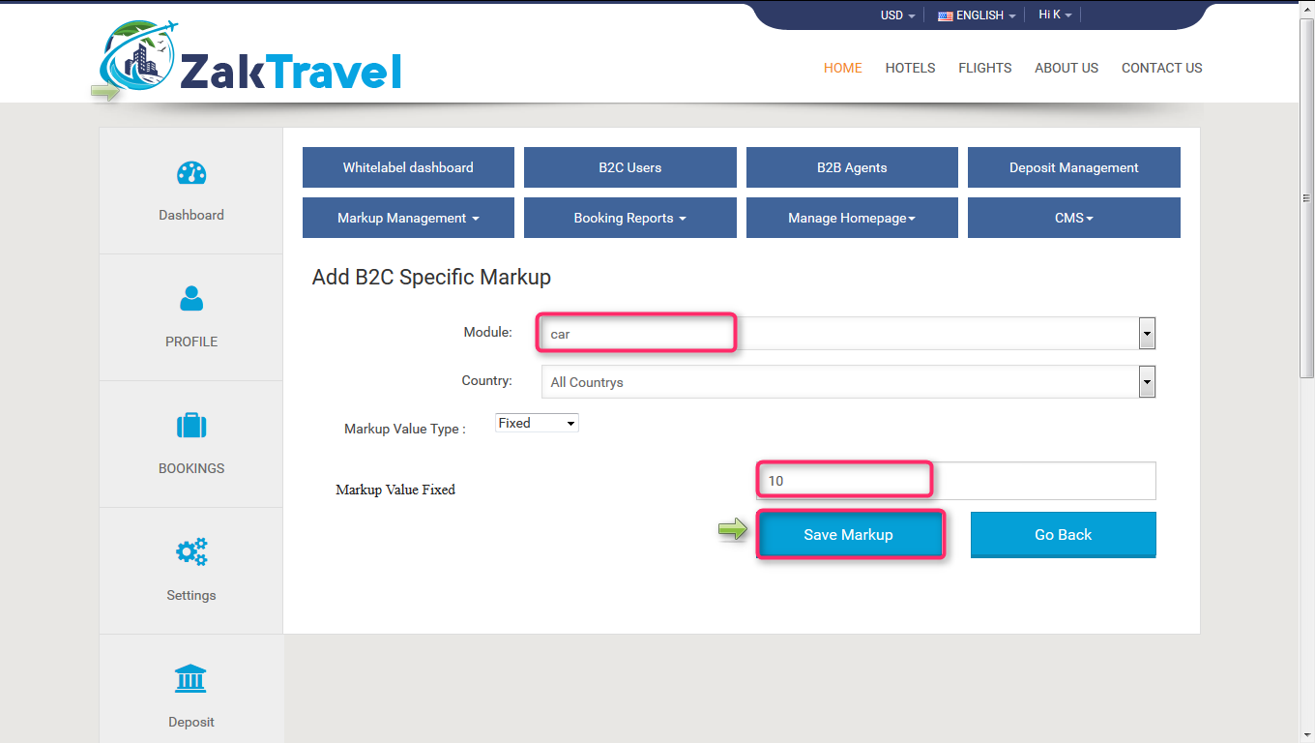

**5.6. Front End without adding markup (B2B2C):** For customer the markup is not added with total fare, so whatever the amount is added at the time of transfer creation that amount will be display only and total fare will display without markup.



**5.7. Markup list in admin and parent agent panel for B2B2C**: Here admin and parent agent add the markup for customer, select the user type as B2B , user name means for which agent admin add the markup, product as a Car , API CRS Car , country and markup type. After adding the markup will display in the list.

**Admin Parent agent**

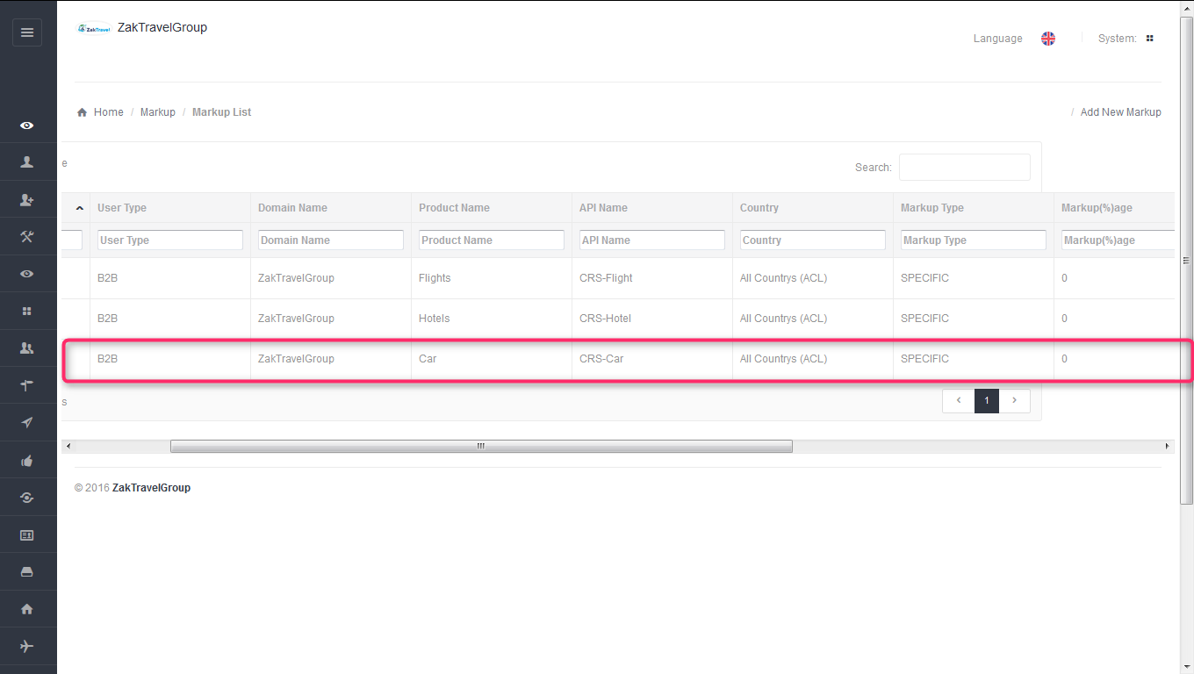**+**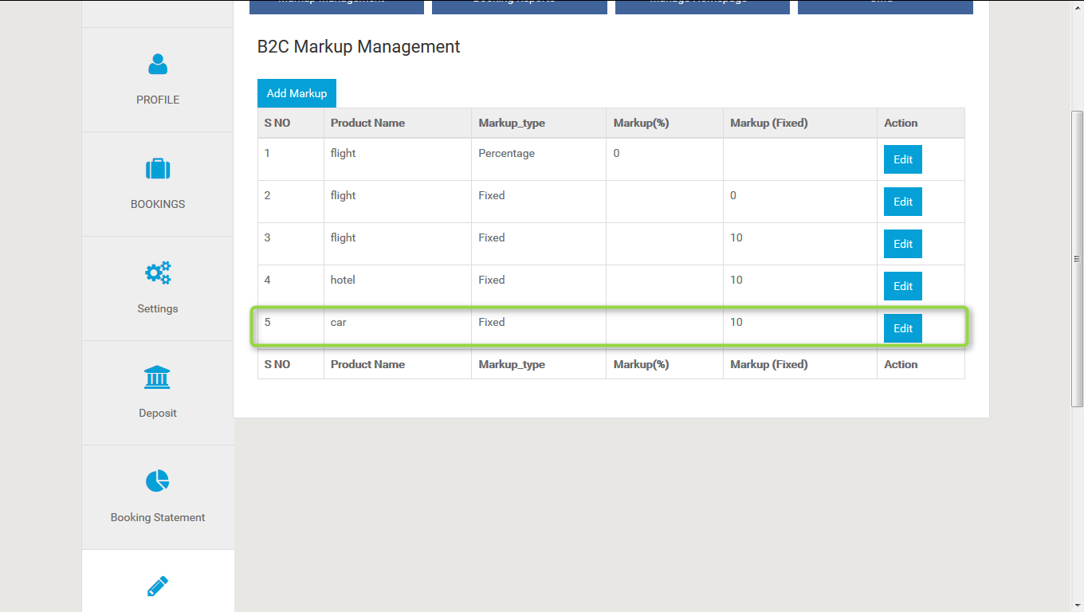

**5.8. Front end with Markup (B2B2C):** Now the added markup will be display with the total fare, for one day the markup added is 30 rupees now and markup will be added according to number of days.

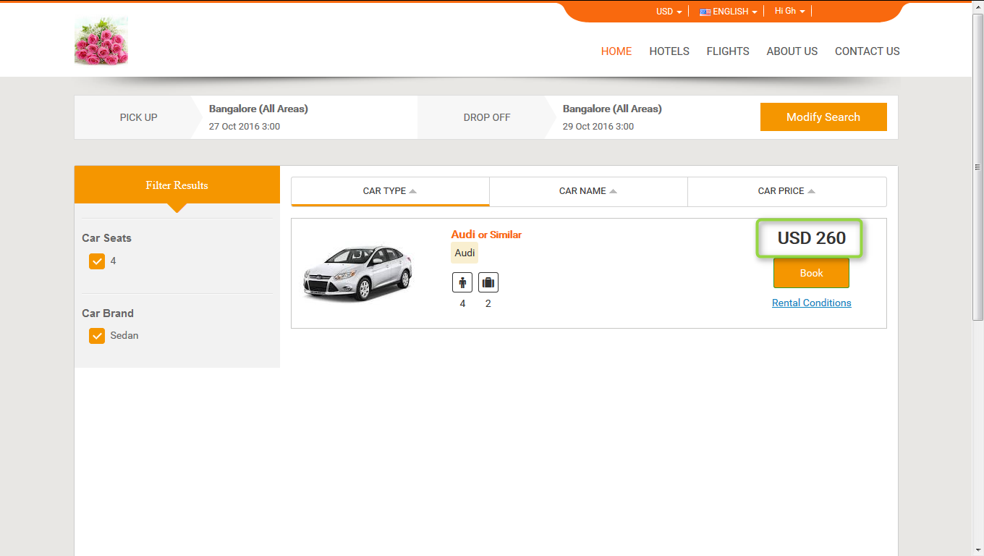

**5.9. Booking for Car:**

Users can book the particular car by providing their personal details. And they will get confirmation letter. Now click on car tab and provide all the valid detail and search for the car. Now after click on book button it will open review, travelers and payment information and click on continue tab it will open the form to enter the personal information. Provide all the valid information and click on continue button and check the check box for terms and conditions.

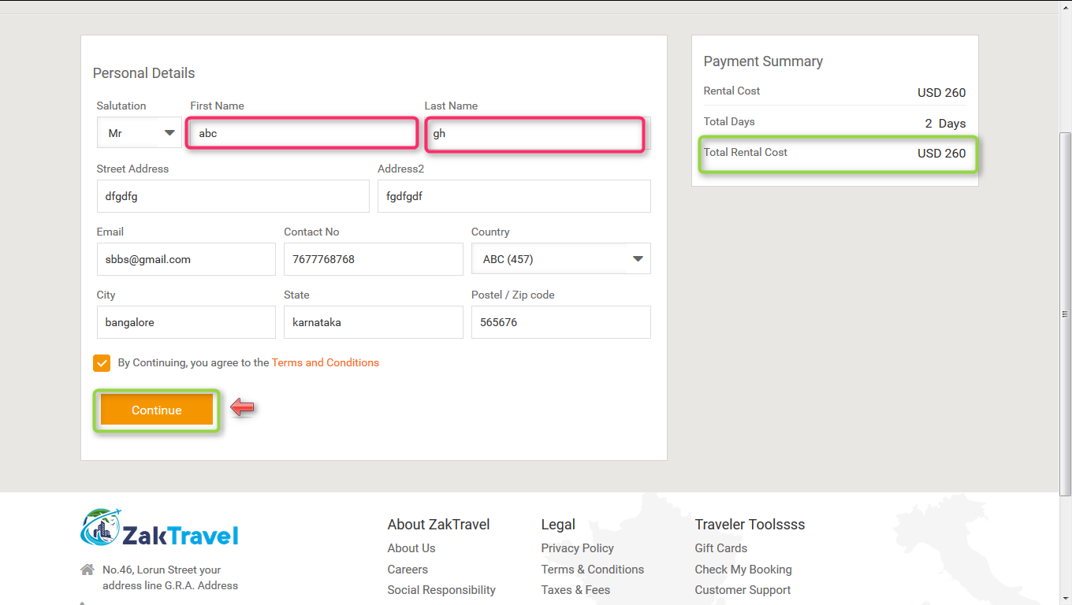

**5.9.1. Voucher page :** Voucher page display after providing all the information and click on continue button and everything will be present on the voucher page like booking status, reservation number, Traveler, date, amount etc.

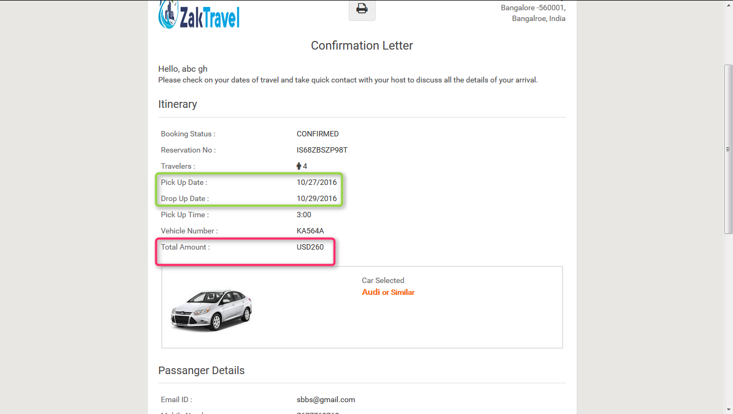

**6. BUNDLE DEALS:**

**6.1. Bundle deal (B2B2C) (Flight, hotel, car):** Now created bundle will display on the home page in best deals and click on bundle deals.

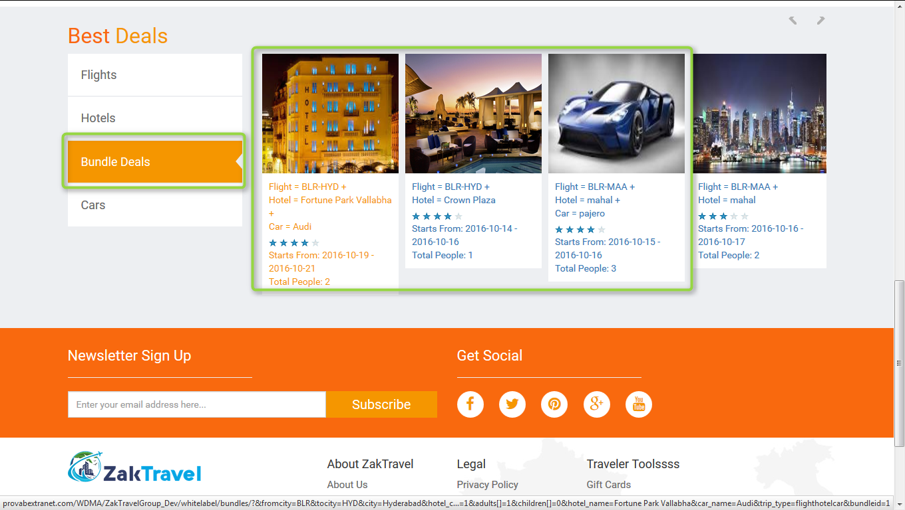

**6.2. Front End (B2B2C):** Bundle will display on front end from where booking will be done.

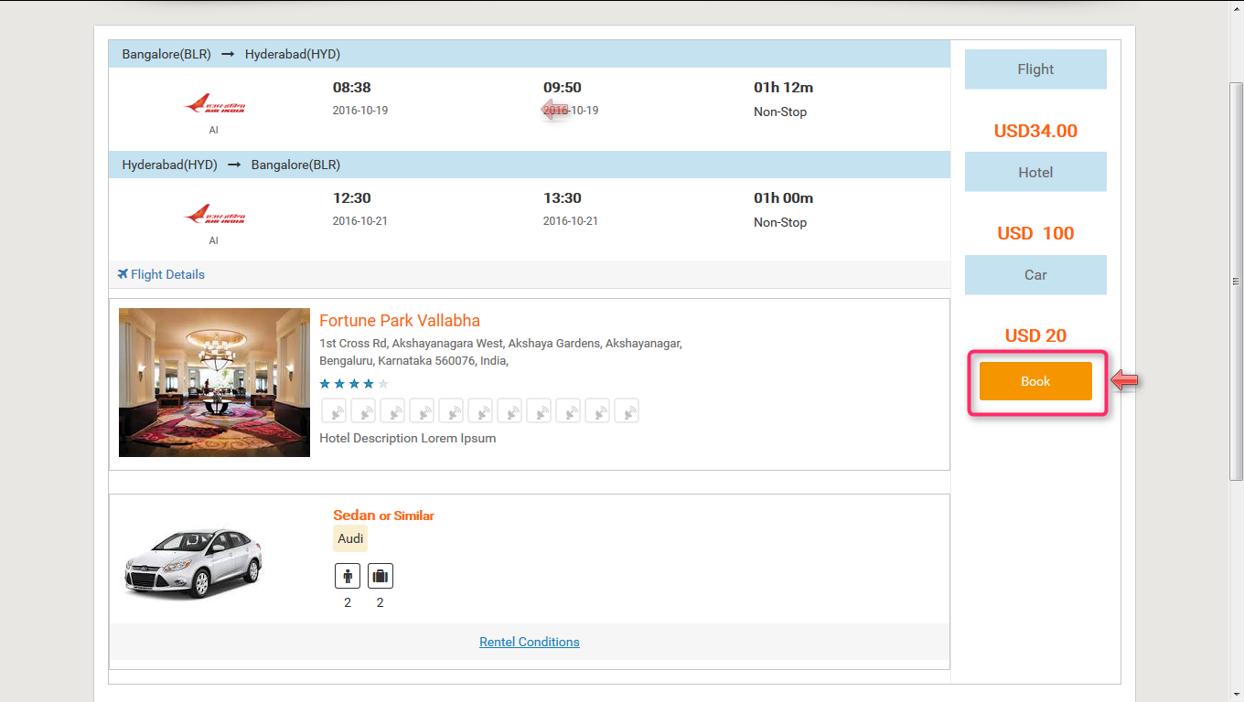

**6.3. Booking Page (B2B2C):** Click on bookand onthe booking page all the information which is given by the user and total amount will be present. Now click on continue voucher page will be displayed.

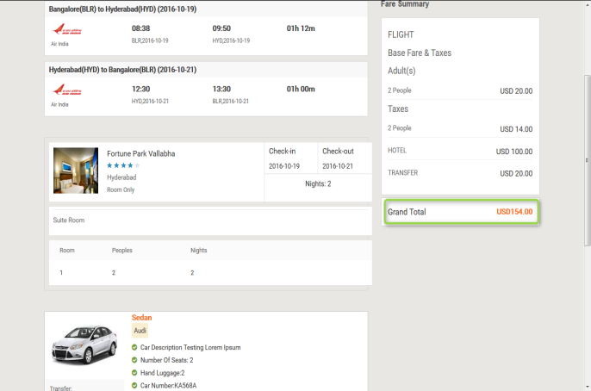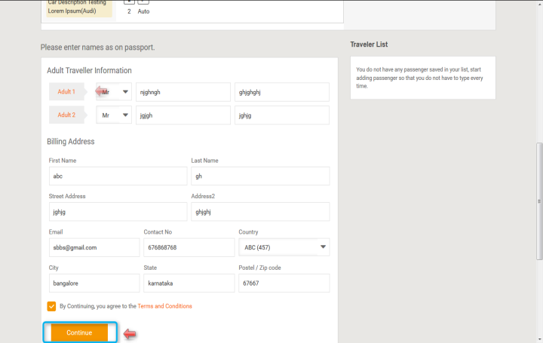

**6.4. Voucher Page (B2B2C):**After providing all the information and click on continue user will get confirmation letter.

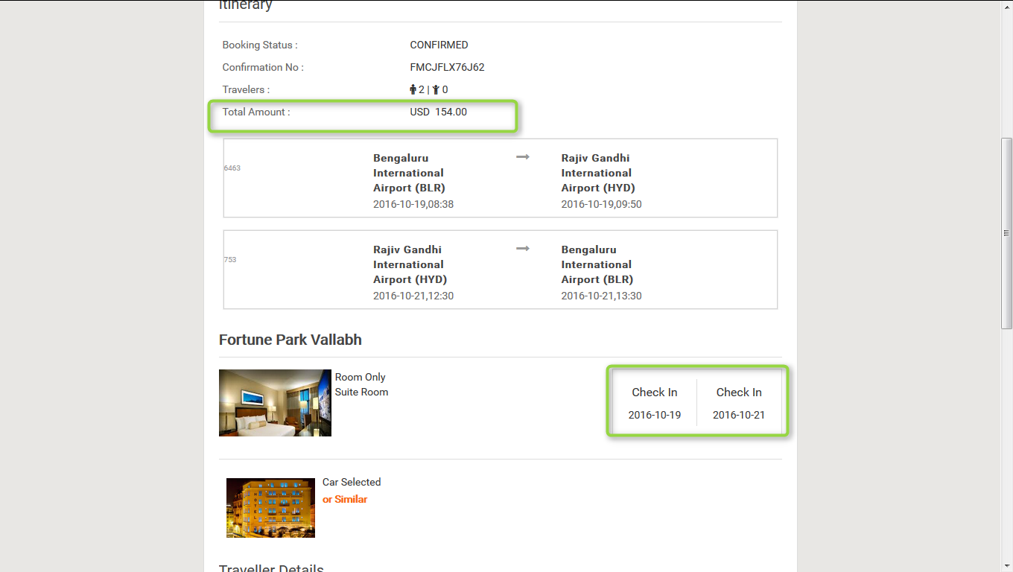

**6.5. MARKUP for Bundle deals (B2B2C)**: Markup is added by the Admin and parent agent, after adding the markup will be added with total fare and display on front end.

**6.6. Before adding the Markup for bundle:** Markup will not display in the list before adding.

**+**

**6.7. Front End Without adding markup (B2B2C):** For a customerthe markup is not added with total fare so whatever the amount is added at the time of rate management that amount will be display only and total fare will display without markup.

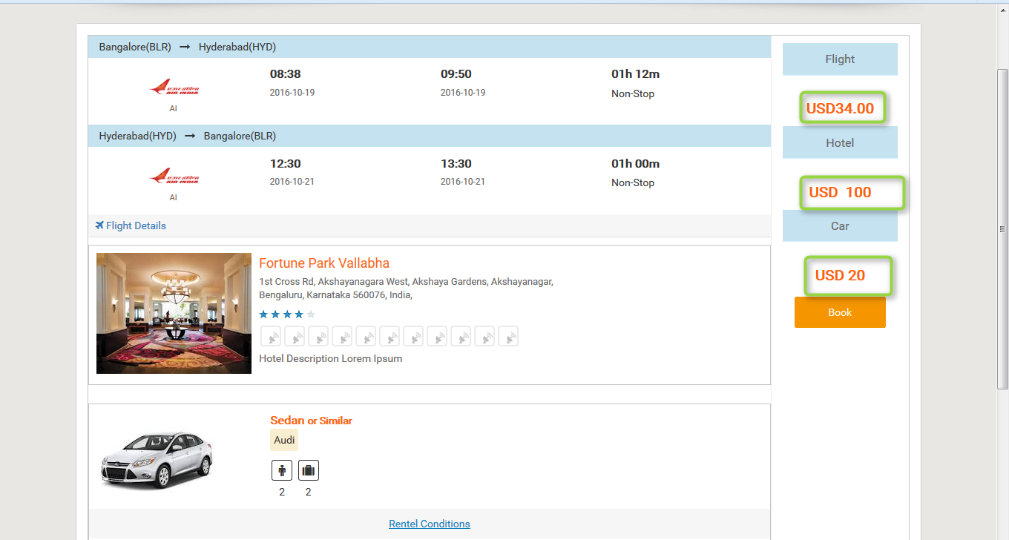

**6.8. Steps to add markup for bundle (B2B2C):** After click on add markup one form will be displayed and enter all the required information like user type, product, API, and markup value type and in parent agent click on markup management and click on b2c markup, click on add markup, enter module, select Markup Value Type and click on save markup.

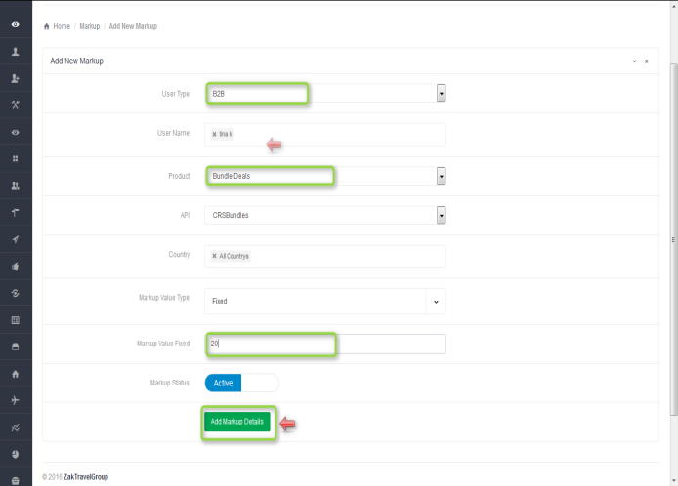**+**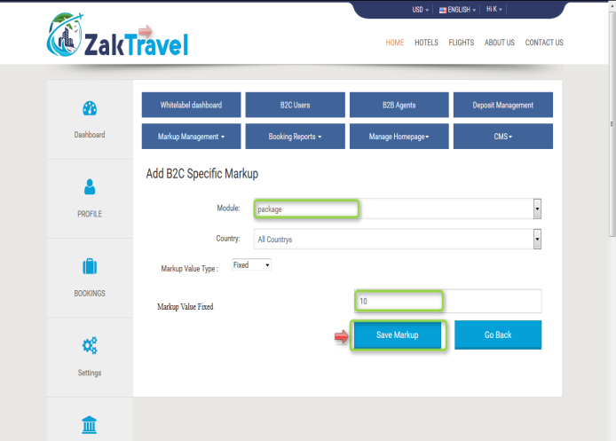

**6.9. Front end with Markup (B2B2C):** Now the added markup will be display with the total fare, for one day the markup added is 30 rupees now and markup will be added according to number of days.

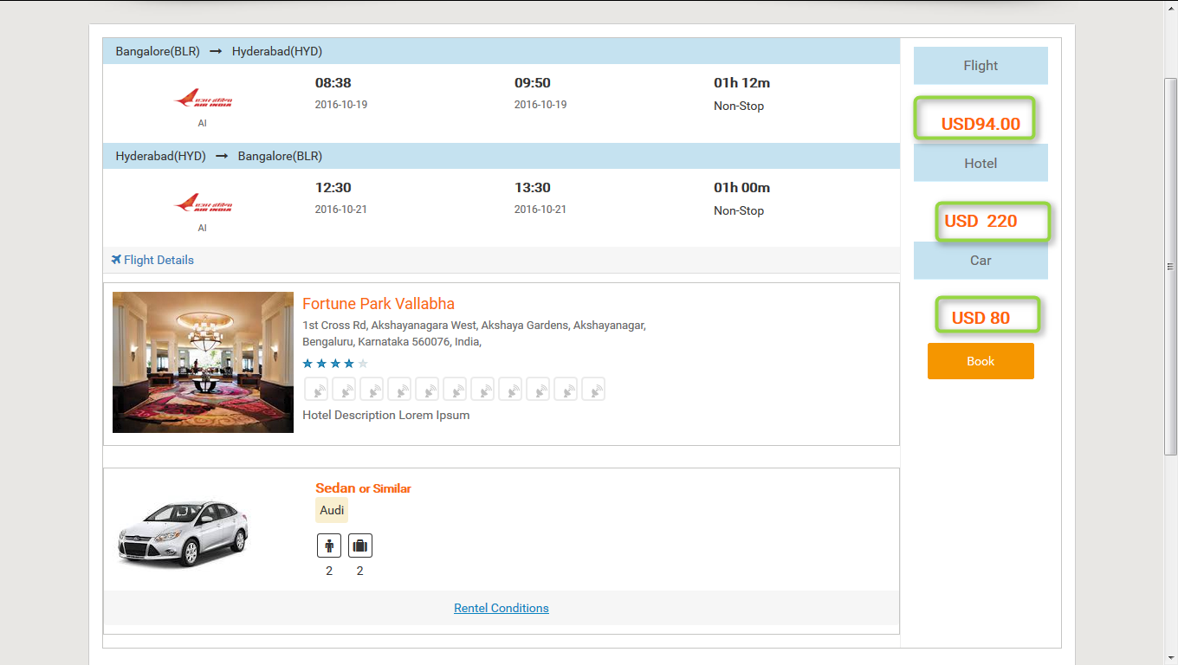

**7. (Flight, Hotel):** Now created bundle will display on the home page in best deals and click on bundle deals.

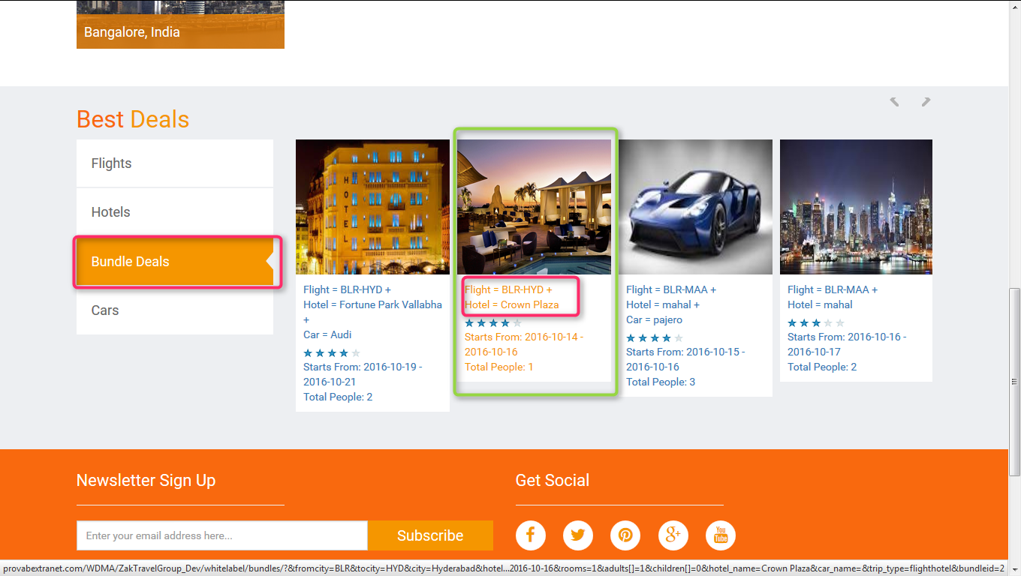

**7.1. Front End (B2B2C):** Bundle will display on front end from where booking will be done.

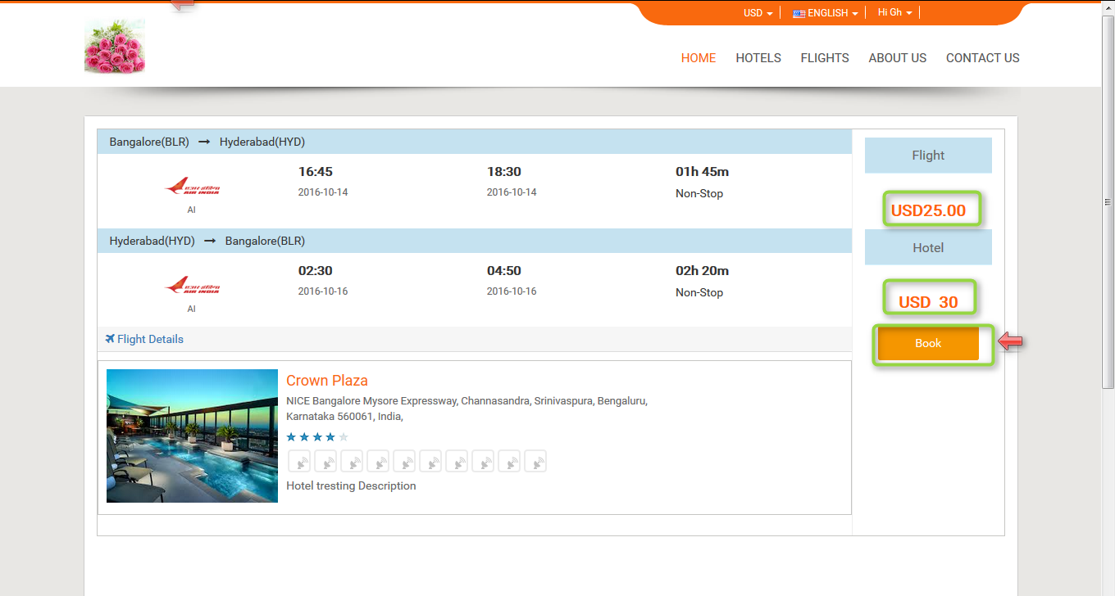

**7.2. Booking Page (B2B2C):** Click on bookand onthe booking page all the information which is given by the user and total amount will be present. Now click on continue voucher page will be displayed.

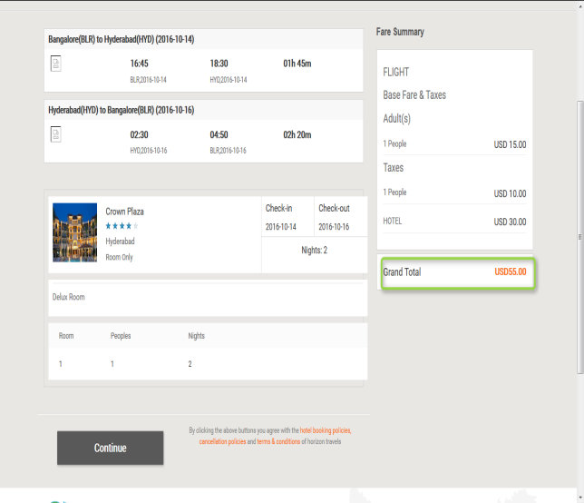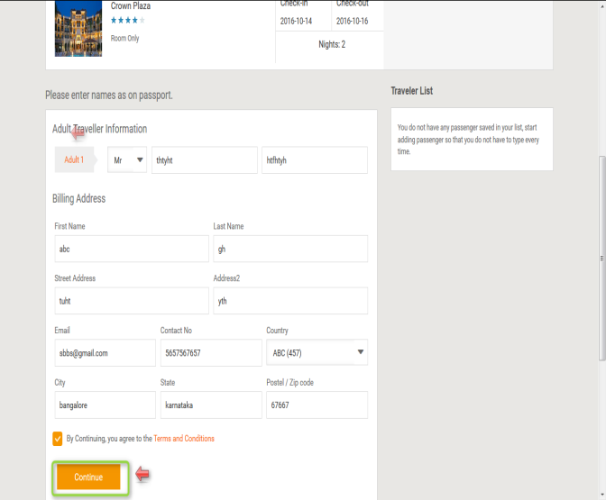

**7.3. Voucher Page (B2B2C):**After providing all the information and click on continue user will get confirmation letter.

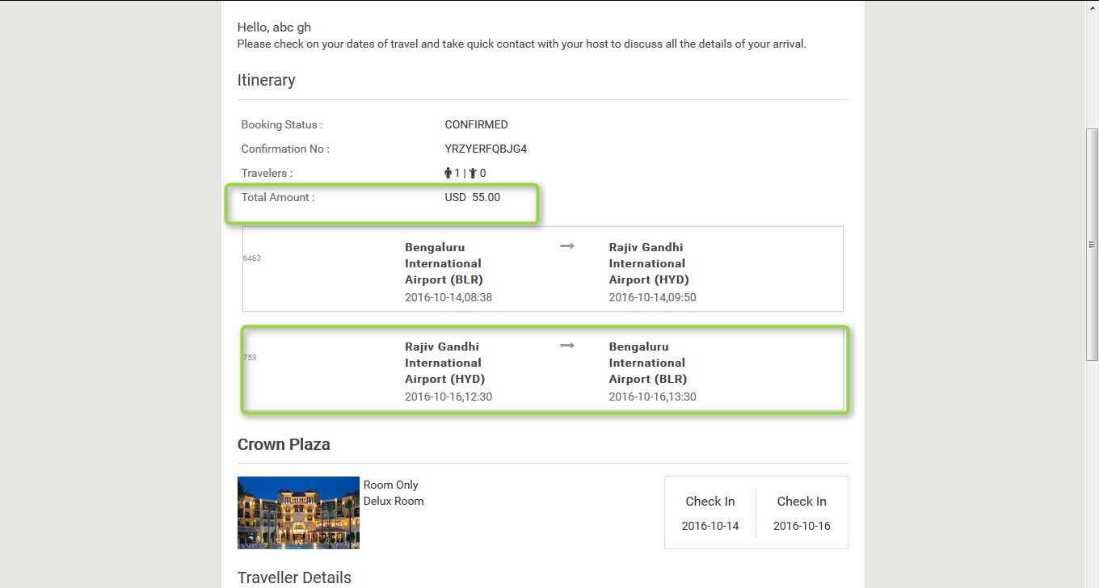

**7.4. MARKUP for Bundle deals (B2B2C)**: Markup is added by the Admin and parent agent, after adding the markup will be added with total fare and display on front end.

**7.5. Before adding the Markup for bundle:** Markup will not display in the list before adding.

**+**

**7.6. Front End Without adding markup (B2B2C):** For a customerthe markup is not added with total fare so whatever the amount is added at the time of rate management that amount will be display only and total fare will display without markup.



**7.7. Steps to add markup for bundle (B2B2C):** After click on add markup, one form will be displayed and enter all the required information like user type, product, API, and markup value type and in parent agent click on markup management and click on b2c markup, click on add markup, enter module, select Markup Value Type and click on save markup.

**+**

**7.8. Front end with Markup (B2B2C):** Now the added markup will be display with the total fare, for one day the markup added is 30 rupees now and markup will be added according to number of days.

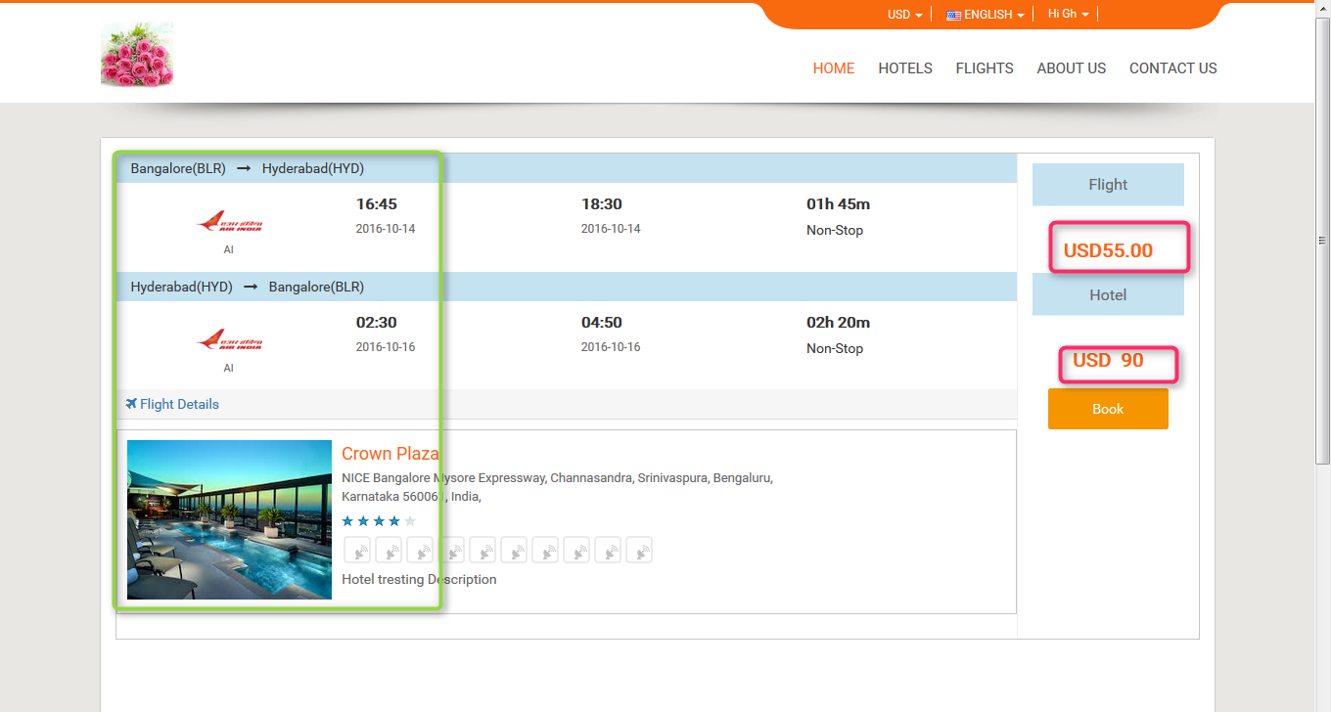

**8. (Hotel Car):** Now created bundle will display on the home page in best deals and click on bundle deals.

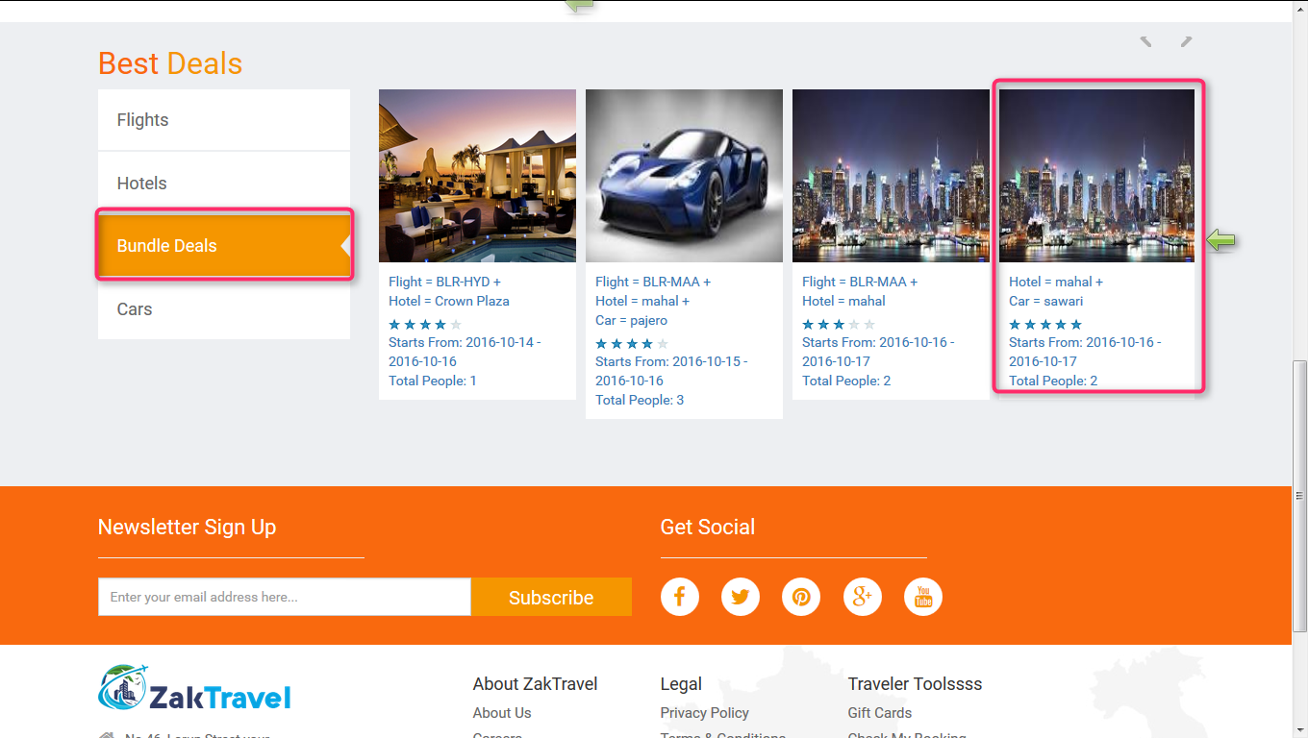

**8.1. Front End (B2B2C):** Bundle will display on front end from where booking will be done.

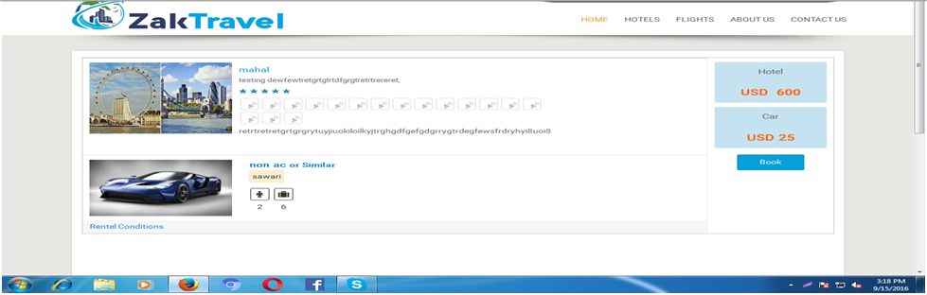

**8.2. Booking Page (B2B2C):** Click on bookand onthe booking page all the information which is given by the user and total amount will be present. Now click on continue voucher page will be displayed.

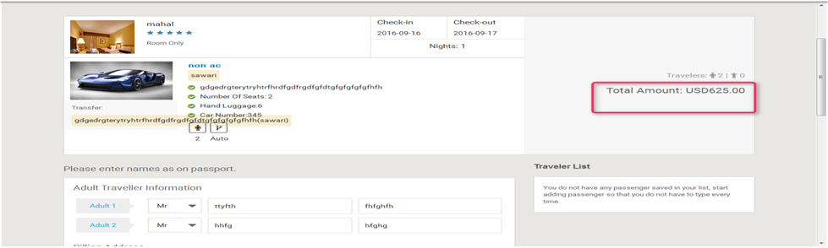

**8.3. Voucher Page (B2B2C):**After providing all the information and click on continue user will get confirmation letter.

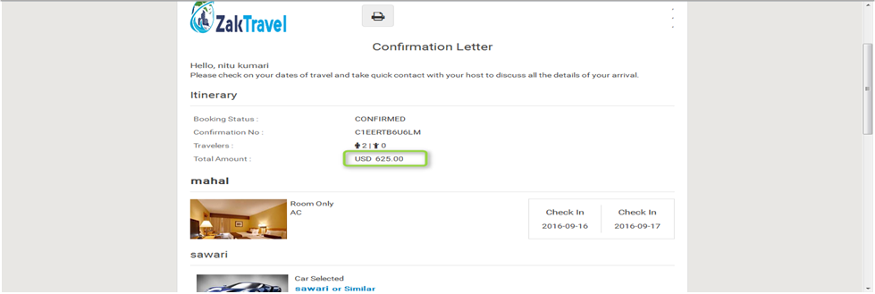

**8.4. MARKUP for Bundle deals (B2B2C)**: Markup is added by the Admin and parent agent, after adding the markup will be added with total fare and display on front end.

**8.5. Before adding the Markup for bundle:** Markup will not display in the list before adding.

**+**

**8.6. Front End Without adding markup (B2B2C):** For customer the markup is not added with total fare so whatever the amount is added at the time of rate management that amount will be display only and total fare will display without markup.

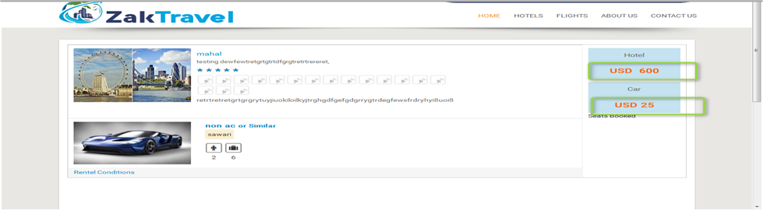

**8.7. Steps to add markup for bundle (B2B2C):** After click on add markup one form will be displayed and enter all the required information like user type, product, API, and markup value type and in parent agent click on markup management and click on b2c markup, click on add markup, enter module, select Markup Value Type and click on save markup.

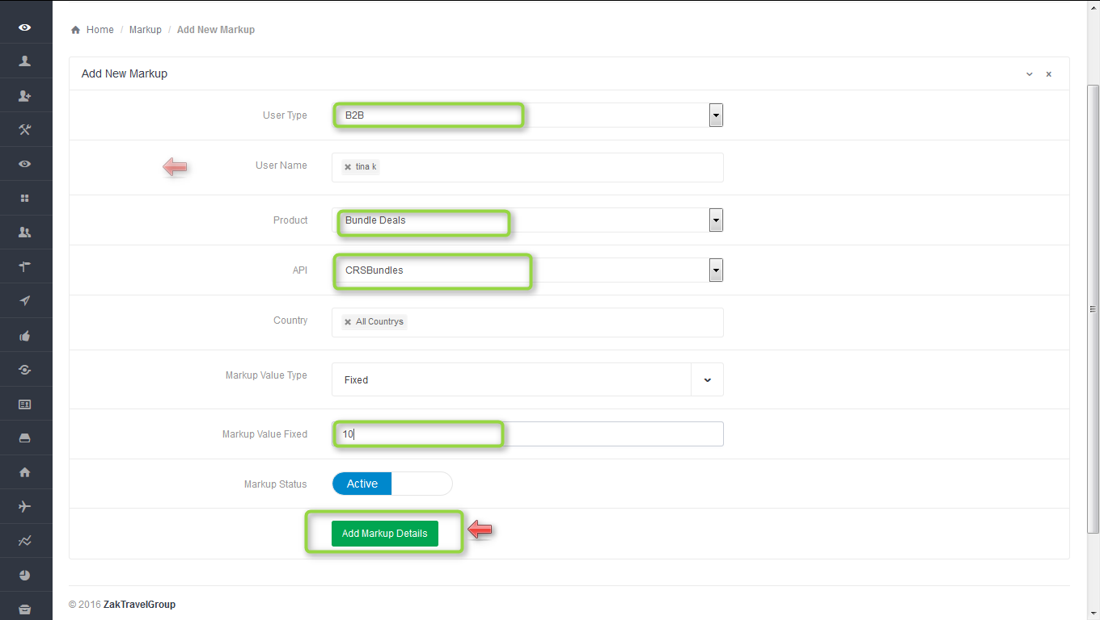**+**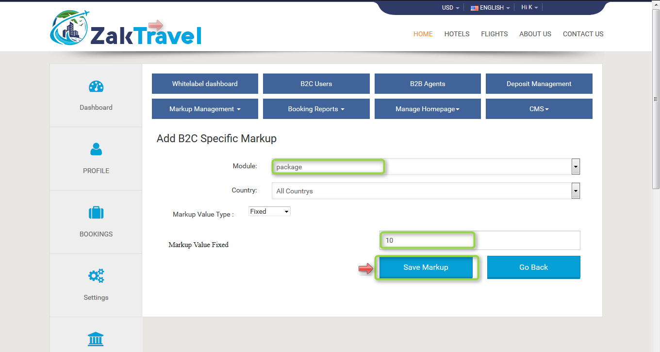

**8.8. Front end with Markup (B2B2C):** Now the added markup will be display with the total fare, for one day the markup added is 20 rupees now and markup will be added according to number of days.

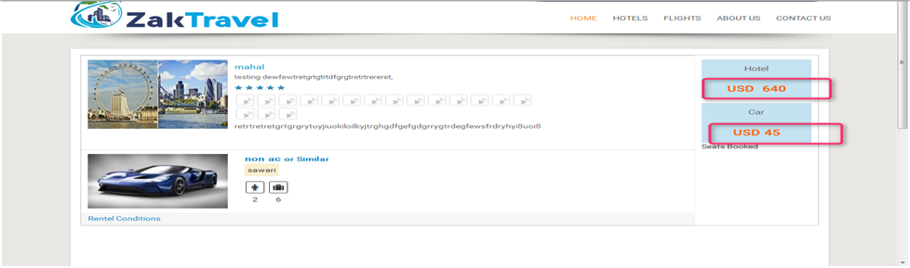

**9. BOOKINGS (B2B2C dashboard):** Here customer (user) can see how many bookings have been done for flight, car, hotel, and bundle and over all booking, conformed booking, cancel booking and Failed / Pending / Hold etc.

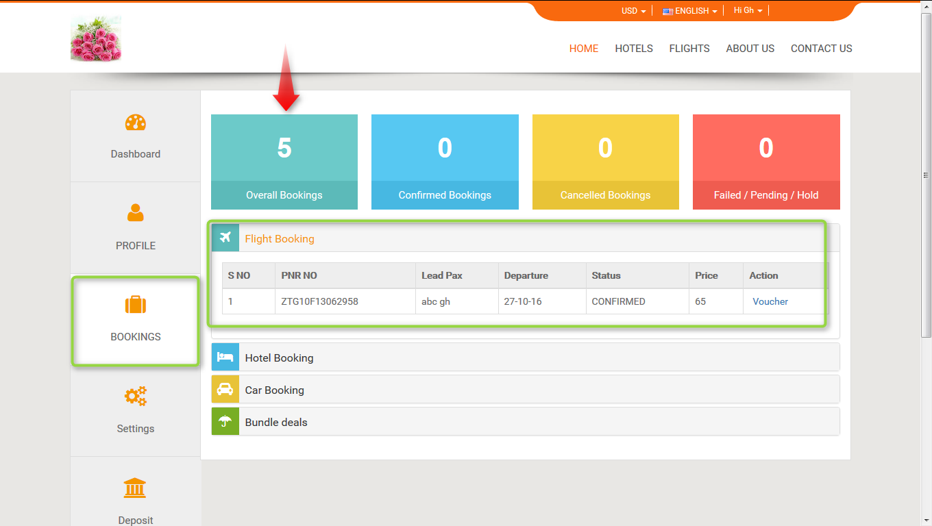

**9.1. Check flight booking:** After click on flight booking it will display how many booking have been done.

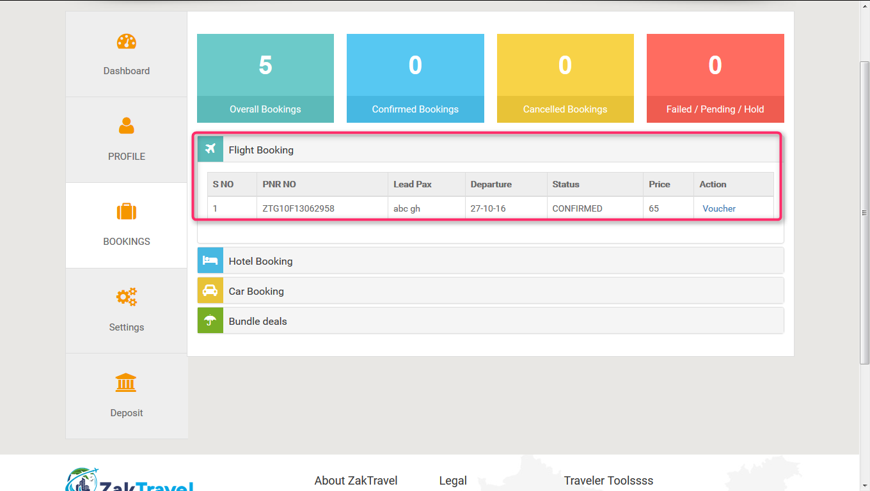

**9.2. Check hotel booking:** After click on hotel booking it will display how many booking have been done.

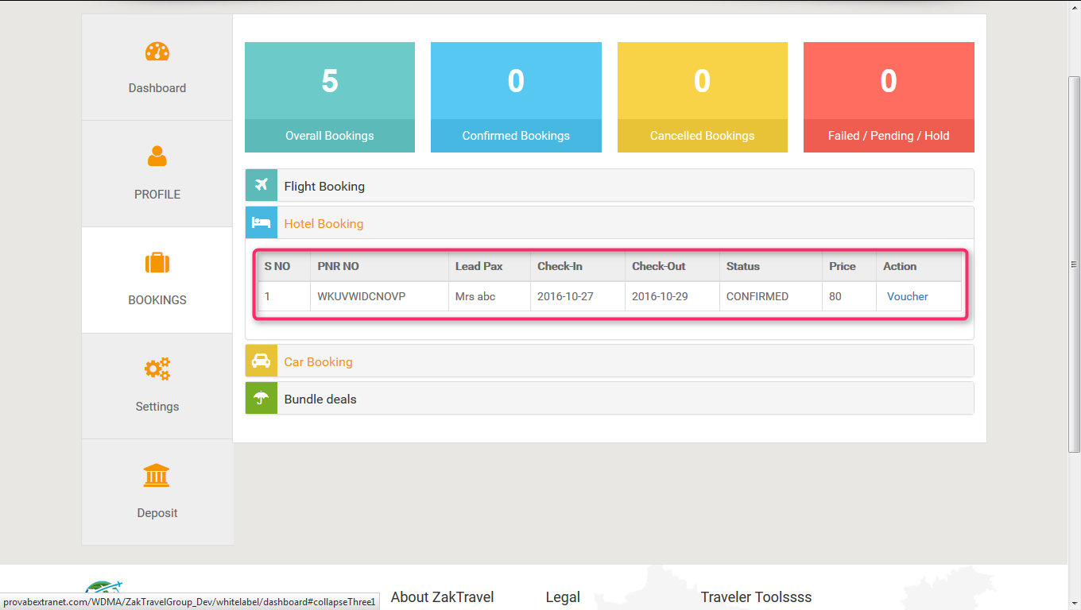

**9.3. Check bundle deals booking:** After click on bundle deals booking it will display how many booking have been done.

